A SIMPLE INTRODUCTION

Hello fellow traders – and welcome to the Black Dog Trading System.

Hopefully you will soon become a Black Dog Trader reaping the regular gains that we, the BD team and other BD owners, are starting to take for granted! I congratulate you on your wise investment and I hope that the Black Dog serves you well for many years to come, forming part of your trading arsenal in the constant battle with the forex market. The Black Dog Trading System (or BD from here on in) is the only strategy that I personally use, but it does no harm to have other big guns on your side enabling you to change tack and attack those markets from a new angle. I am all in favour of extracting profits no matter what it takes. It sure beats losing! But, like I say, the BD is all I need to make a comfortable living, so I’ll stay with it.

You have made a very wise decision in your investment. The strategy is currently performing very well and profits are made consistently. There is no reason to suppose that this will not continue indefinitely.

Please take the time to study the training material. The Black Dog team trades the strategy on a daily basis very successfully, this is achieved by following the rules of the system rigidly. It cannot be overstressed that diverging from the rules will probably result in failed trades. The rules are not difficult to follow, and there are only a few of them. They will protect you. The system works.

Should you have any problems at all please do not think twice of contacting the Black Dog team. You have shown your confidence in our system by making the purchase, we will be there for you to get you up and running as soon as is possible, and at any time in the future. This website is dedicated to the Black Dog and we hope that you will frequent these pages often, free downloads of strategies and forex information are available to Black Dog owners to use as they see fit, with more to come.

Please be aware that no member of the team is a computer wizard, we are traders. But we will try to solve any problem you may have with the system and its application. We cannot offer trading advice or tax advice. This must be your responsibility.
All the contact information that you will require is included and, personally, I hope that you make use of it. Keep in touch. The Black Dog family continues to grow, and we are in this together. All of us want to make money, agreed.

I wish you all the good fortune in your trading endeavours and long may it last.
There are days, I’m sure you will agree, when things get a little boring. Trading is not the most exciting pastime there is. And it’s that boredom that led me to thinking of starting a website, trading together with some local guys (no females as yet!), and ultimately offering the BD to anyone who would care to use its simplicity in making some cash. Hence this document.

Let me start as I mean to go on; we Yorkshiremen tend to get straight to the point so I won’t linger on this intro. I am not a writer, I am not a salesman, nor am I a philosopher. I am, believe it or not, a full time trader, a trader who has developed a successful strategy to extract cash from the greatest bank in the world without too much hassle. So why sell it?

What would you do? C’mon, let’s be honest!
Answer: to generate extra income to place into a trading account which would enable playing for higher lots. Simple. Don’t ever listen to all the bull about: ‘the markets are big enough for all of us....’; ‘I like to help less experienced traders just starting on their careers....’; ‘many traders using this strategy won’t affect the market....’; ‘by making this affordable to new traders, blah blah blah’. Honesty please. Money makes the world go round, so I‘ll not labour the point.

Talking about honesty, the reason this page is staring at you is because you want to make money, and lots of it. True? With this system you WILL be profitable, if - you - follow - the - rules. This is very important and I suppose its the same with any system but more so with the BD. The information in the following pages presents a very simple and uncomplicated means of trading the forex markets so please follow the rules. Simplicity is the key, a key I found after almost eleven years of trading. Simplicity. I’ve traded ‘complicated’, and I’ve traded ‘very complicated’, but it’s the simple ways of trading that produced the consistent gains. Bear that in mind. Simplicity. Wins every time.

The well-known acronym used in trading is KISS … Keep It Simple Sir.
I agree with that statement 100%, and its what you’ll find here. Will there be regular, high-probability trades? Well, that all depends on your choice of time frame and what your goals are. I trade the 15 minute TF but my profit targets are not too large, so almost every day there are quite a few. It’s managing them that poses the problem. I can cope with four open trades, not more. But that’s me, you may be a very capable trade manager, so..... go for it!

Please read the chapters, links are at the top of the page, in their numerical order to obtain the full benefit. Its easy to jump back and forth to fully understand the gist of a particular point, any problems then e-mail or skype me straightaway. Don't hang about and let's get earning together!
What is a pip? What do brokers do? What are probabilities? What are fundamentals? Well, you’re going to have to find out elsewhere because explaining these is not my job. You won’t find the answers on these pages. There’s no fluff here, no padding on page after page to justify the often very high cost of an e-book. What you will get is some of my (experienced?) thoughts along the way as they relate to the subject in hand using a blue font. Once or twice, I may rant on for a little so I apologise in advance. Don’t take everything I say at face value, check it out for yourself. These pages tell the story of how I trade, and of how I trade this system. Plus there will be a few words on how I developed the system. I am now profitable after a long forex journey.

Let me shorten that journey for you.

The Black Dog Team

North Yorkshire
May 2008

Abbreviations used in this document:
BD | Black Dog
TF | Time Frame
SL | Stop Loss
TS | Trailing Stop
DS | Disaster Stop
TP | Target Price
EMA | Exponential Moving Average
MA | Moving Average
MACD | MA Convergence Divergence
MTF | Mini-trend Finder
SES | Standard Entry Signal

THE BEGINNING

1. In the Beginning, Darkness.

Over the years and looking back (I refer to my trading years), after the initial costly ‘settling in’ period that most new traders go through, my discipline became ok, my timing was ok, in fact most things related to my trading were not bad at all, eventually I made money, good money. I have primarily bought and used systems developed by other people, studied them, applied them, and made money. Not so at first, the ‘settling in’ period of maybe 18-24 months were disastrous, but later. So what’s the problem?

Well, none really. But bear with me; let me carry on for just a little while. I have the same background as the majority of traders. By traders, I mean trading for oneself, not as a job of work, but for personal gain. Yes, I have blown accounts in the past worth x000’s of pounds and this was painful, very much so. This was in the early years of course, whereby I did have the presence of mind to stop trading, take stock of what I was doing, analyse my mistakes, and then study, study, study. So you could say that those lessons had been well and truly paid for the hard way. But nevertheless, well and truly learnt.

In those early days, I had a scant trading plan which I rarely followed anyway, discipline was lax, fear and greed were part of my trading, I often went fishing for tops and bottoms, money management was zero, I was playing a host of different markets, and to top it all off, overtrading. A recipe for disaster, and that is exactly what followed. If the market was topping out and starting to turn, I would enter long and get stopped out in no time at all. The same story at the bottoms.
But, in spite of those early disasters, I could see that there were ample opportunities for making excellent returns on ones investment if only I could find that elusive plan, scheme, method, call it what you will. I'm pretty sure that millions of traders have gone through the same procedure. Well, I was determined.

So, to cut a long story short, and after many days, nights and weeks of study, searching the web for good systems, then working on my ‘inner game’ …. my head, I came to the point where I eventually became moderately successful at this game of trading the currency markets.
Never the one to be satisfied I then asked myself the question, “where next?”

Although I had traded another persons’ system(s) for quite some time, and good though it was, I was never fully satisfied and was hankering after my own, one that suited me. It would be nice to be successful with my own system, a system that was all my own work. But what was I looking for? What characteristics should it have? What qualities? What features did I want my own system to possess? I had some idea of what I wanted it to do.

Basically, it should eliminate all of the minuses mentioned above and hopefully keep me on the straight and narrow. Like everyone else I bought all the usual books, courses, systems, T-shirts etc., and ended up using one of the first methods I had come across. No progress was being made.

This was no good, I was back to square one. So, I spent a great deal of time just thinking about what my system should incorporate before attempting anything. The usual tenets sprung to mind, ‘the trend is your friend’, ‘let your profits run….’ etc.

Ok, the market moves in waves, this is an indisputable fact; you only have to look at any chart of any time frame to see this. Now I’m not saying let’s use some form of Elliot wave system, that's all been done and anyway I am not an advocate of Elliot wave theory, but the waves are there for all to see nonetheless. What I decided and wanted to do was to ride those waves. I then made a list of how I hopefully would achieve it. Let’s do the same.

These are the points that I came up with that I wanted my new system to address, but above all, to find answers for. It should enable me to trade in a much less riskier fashion, and importantly, to trade with the trend. After all, that’s what everyone says, is it not? So, here’s my list:

a. Must trade with the trend
b. A chart set-up which is good for all currency pairs
c. A chart set-up good for all timeframes
d. A chart set-up which is simple, simple, simple
e. An audio alarm
f. Must stop me from overtrading (very important)
g. Must stop me from fishing for tops and bottoms (also very important)
h. Must get me into the big moves of the day
i. Must keep losses to a minimum
j. Must tell me when to exit
k. Must be user-friendly
l. Must enable decision-making at a glance
m. Multi time-frame trading
n. Must give unambiguous entry signals

Wow, that’s a lot to ask. Did you say that you wanted to keep it simple?

I did.

The darkness was beginning to lift, now I had something to work with. I knew what I wanted and roughly how to achieve it. Only through days and weeks of testing and analysing could I hope to arrive at the final result. You would not believe how many hours went into the development of the Black Dog System, but that is a very long story and you have paid for the end result, you will not be disappointed when you see your account beginning to grow.
I believe that it has all been worth it because of the benefits I now reap. As a Black Dog user you will now also reap those benefits. Before we go any further, I’m going to assume every one can read a chart and has a basic understanding of technical analysis, if not then call or e-mail me, I'm pretty sure we can get you sorted out regarding this; details at the end. In fact, any problems or questions whatsoever regarding the system and you’ll find that I’m available, usually most of the time. I do have another life so please be patient.

There’s going to be no fluff on how the markets work, or what makes a good broker. Not my problem. It’s my task to present to you what I think is a very good system (my words) that will lead you to some very good profits (ditto). In the last three weeks of trading (as I write), this system has generated almost seven hundred pips! Not bad at all. As with every system there will be losses, but here, we keep them to a minimum and take them in our stride.
So what’s the story so far?

I was a newbie trader who lost big time. Fact.
I stopped trading to study, study, then study some more. Fact.
I used systems purchased from the web and did ok-ish. Fact.
I still hadn’t made a fortune. Fact.
I decided to build my own system from the list. Fact.
After many months, the BD had definitely arrived. Fact.
And finally, my earlier losses have returned to their rightful owner! Glorious fact.
The BD team trades this system every day, and we do very well. As an owner you are invited to the forthcoming website as a member with full member benefits, you are invited to contact us at any time (UK trading times please), and to receive any updates to the system. In fact, you are entitled to everything that we at BD Trading enjoy. Please join us.

Ok, Let’s press on.

METATRADER

2. MetaTrader

First and foremost, this chart set-up was devised on the MetaTrader charting package, and is the one we use. The beauty of this is because it is free real-time charting which is available from many brokers eg, Interbank, Alpari, etc. Totally free. Just register and then download. You do not need to hold an account with a MetaTrader broker, only register for a demo account. You may use the charts, but trade with your own broker if you wish. You can open a demo account first to get to grips with this system and then when you feel comfortable enough to ‘go for it’ you can open an account with real money or 'go live'. My brokers, Alpari UK, have a minimum amount of $200 to open an account. You can also trade microlots with them making the learning process less painful if you should suffer a few losses during your learning curve.

If I may just repeat myself here: until you are fully conversant with all the rules, machinations, and workings of the BD system then please, please restrict yourself to trading very small lots. i.e., DON'T RISK THE FAMILY JEWELS!!

In most documents you will find that it is at the end where it is recommended that you demo trade the system for a few weeks or so until you are up to scratch. I'm going to go against the flow and mention this at the beginning! It is my view that demo trading, or paper trading, holds no value to the prospective system user apart from learning how to click certain buttons on the trading platform and becoming proficient in its use. 'No bad thing there', I hear you say. I agree, but I feel that demo trading can lull you into a false sense of 'hey, this system's not bad', when in fact trading with cash is another totally different beast. Pray, use microlots to begin with and forget demo trading. At least you will have some interest if there is cash on the line, albeit pennies.

This is not the place to go into the finer workings and instructions for the use of the MetaTrader charting package. My PC skills are very limited, but if I can learn the refinements of it in a relatively short space of time, anyone can! That being said, it’s good to be up and running in the shortest time possible, so should you have any problems whatsoever setting up your charts feel free to contact any of the BD team immediately. We would be only too pleased to assist you. If you are not familiar with MetaTrader I'm afraid that you will have to do as I did over a period of time, and that is to just play around with it until it becomes embedded into the old brainbox. Don't try to rush things along as it may prove expensive, the markets will be around for a long time to come. We are always here to help.

I have no idea if the BD set-up can be arranged on any other charting package. I haven’t tried. The settings are nothing special, just my attempt to address the problems on our famous list. I think it is a successful attempt.

Currency trading can be expensive and (if you do not know what you are doing) an excellent method of reducing the contents of your wallet. Now there is an understatement. So it makes sense to utilise the facilities provided by MetaTrader considering that some charting packages with a live data feed can cost anything up to $150 per month. Maybe more. We are only on chapter 2 and making/saving money already! MetaTrader maybe lacks some of the more complicated algorithms and indicators that the "successful" traders employ, but it has far more than we are likely to need so why pay for things that are not required? Remember simplicity?

In the next chapter we'll look at some charts and start laying the foundations for the Black Dog system, but for now I think it's probably best not to go into the setting up of our charts until we come to the particular indicator in question. So, I'll draw this chapter to a close. In the meantime, feel free to play around with your MetaTrader charts.

People have already contacted me regarding the use of Fibonacci retracements and extension levels and how they can maybe assist with entries and exits. I have no problem with this but I cannot give any advice. I think of myself as not an unintelligent person with a flair for maths, English, history, geography, and the sciences, etc. but for the life of me I cannot see how those idiotic numbers can in any way be remotely connected to the currency markets, or any other market for that matter, numeric or brick. Choose your own numbers and they will work just as well, and in most cases better.

I personally do not use Elliot Wave or Gann for similar reasons. Just the word 'fibonacci makes me shiver. If it works for you then use it. This, I think, is the best advice. Personally, I think it's the first step in complicating matters that shouldn't be complicated. Just a thought.

TIME FRAMES AND INTRA-DAY

3. Time Frames (TF)

Well, this is a difficult one. What time frame (TF) should you trade? It all depends on your circumstances, your lifestyle, your job, your family. In fact any number of possibilities can influence your trading time frame. It's just something that you need to work out for yourself, unfortunately we at BD cannot assist you in this decision. If you work full time then the Daily charts are probably the best TF to trade, or maybe the four hour charts (H4).

Me? I have a patience problem. I cannot trade anything higher than a 15 minute TF. This is not to say that there are no trading opportunities on the higher TFs, there are many as we will see shortly. But I must explain to you why I trade the 15m TF as most of the charts shown will be 15m. Now, I usually trade the 15 minute timeframe simply because I can find three or four decent trades in the morning (usually on different currency pairs) and forget about trading for the rest of the day. Who wants to be in front of a computer all day? So I’ll use 15m charts in my explanations, but all timeframes can be traded using this method, it’s pretty flexible as we'll see. I must also add that I am pretty impatient when it comes to taking profits. A throwback to my old 'losing' days I think. We'll have more to say on this aspect of my trading later and how I've turned it to my advantage. Anyway, here's the trading TFs that you may wish to consider:

5m = five minute TF H1 = the one hour TF
15m = 15 minute TF H4 = the four hour TF
30m = 30 minute TF D1 = daily TF

Let’s have a naked chart and a first look at MetaTrader. Here’s the CADJPY 15 m. It is showing about two days worth of price action, this is why the chart is not very clear. It is showing a lot of information. The vertical dotted lines represent midnight GMT.

CHART #1
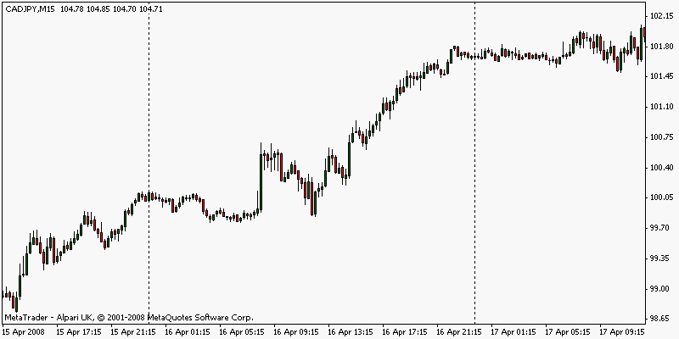

There are some really good moves here that could have generated lots of pips for the savvy trader. My job here is to get you into those moves with minimal risk and the maximum profit. I look for up to four moves, like those above, per day. They don’t happen every day regardless, there are flat days. It’s not just the CADJPY that presents moves like this almost on a daily basis, most pairs show similar movement. The GBPCHF on the next chart also exhibits some great intra-day moves.

CHART #2
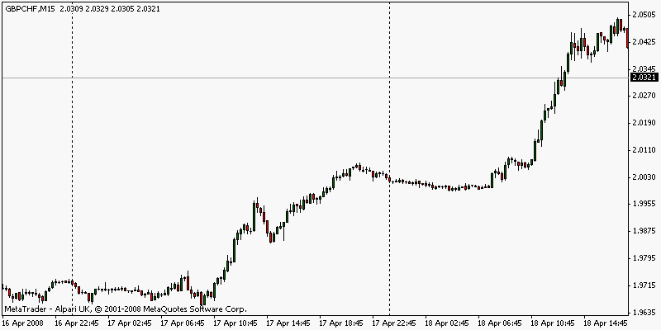

If I hadn’t told you that both the charts above are of the 15m TF, could you have guessed what time frame they were just by looking at them? Probably not, they both appear to be very different.

Do this with some of your own charts on different time frames; try them all from 1 minute up to 1 month. Use a naked chart. Even the 1 minute chart resembles the 1 month in the majority of places.

The point I’m trying to make here is that this method works very well on the 15m time frame, so why not on any other?

I confess to not having the patience to trade the daily time frame (TF), or even the H4 or H1. I do, however, spend all my trading and study time on the 15m TF. You may have a full time job, in which case the 15m TF is not much use to you, the daily charts (D1) would therefore be more suitable or perhaps even the H4.

It’s really horses for courses. Whatever TF suits you. Consider the chart below of the GBPCHF again but this time its the Daily TF. In appearance, there really isn't much difference between all three charts. This statement bodes well should we wish to trade any time frame that suits.

CHART #3
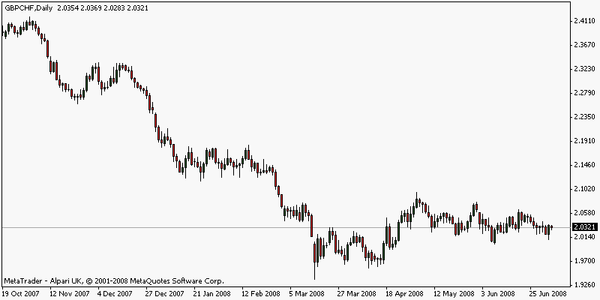

Intra-day Trading Times

To avoid confusion I shall quote all times as GMT. Although in the UK we are at present on BST (British Summer Time) we’ll stick with GMT.

If we are going to trade intra-day on a TF like the 15m chart then we really need the market to be moving somewhat in order for us to gain our quick profits, we also need to stay out of the market at those times when hardly any movement occurs at all; a trading range. Trading-ranges can be very expensive. Where you live will dictate the times when you are able to trade, obviously, but living in the UK, I find that the best times are from the London open to the New York close. I don’t place any new trades after 18:00 GMT but I would be happy to let open trades run beyond this time if they showed promise.

I close all trades before finishing for the day, no matter what time although I have been known to stop up all night nursing a trade to completion. But it must be worthwhile and it’s not very often.
Trading the daily charts, and possibly including the higher time frames, does not have this problem of picking and choosing your trading times. The H1 (1 hour) chart also sees some good moves crossing different sessions so the time constraints do not apply.

So, why these particular times for trading? Well, you only have to study any 15m chart to see that activity falls off after about 18:00GMT until the next day at around 07:00GMT. This doesn't happen every day of course, nothing is for certain in forex. What we are looking for are the flat areas to avoid in general. Becoming stuck with an open trade in an intra-day trading range will more than likely result in a losing trade. Look at Chart # 1 & 2 above and notice how level the price bars become around the vertical dotted line areas.
Yes there are some good moves between the times mentioned in the previous paragraph, but more often than not, there isn't. Let's not risk it as this only reduces our chances of enjoying profitable trades.There are plenty of other opportunities when the market is more active.
Consider the following sentence:

We must take into account anything that reduces our chances of enjoying profitable trades. Period!

In my trading I certainly consider fully anything that may be detrimental to my account and that means avoiding the times mentioned above. And so should you. I should add here that I am usually finished trading well before the 18:00 threshold as I have made my profits for the day using the BD system. We'll talk about this later.

It’s at this point that I think we should start getting some rules together and reinforce them along the way. We only have two 'written in red' rules and here is the first. So:

Rule #1

For intra-day trading on time frames under one hour, trade only from the London open until 18:00 GMT. Close all trades for the night.

Our two 'Red' rules are so important for the simple reason that they save you lots of money. Please trust me on this. Let’s just reinforce what we have so far. Have another look at both charts above. Please, scroll back as far as you like on any chart of your choice, that's any currency pair, to make sure rule #1 is understood. Notice how activity is much reduced during this period. There are plenty of other opportunities to trade during the more active periods and the BD system will generate lots of trading signals (even during the non-trading period); let's just make sure that we act on those signals where there is more of a chance of success.

I hope this explains clearly the need to avoid trading this method after 18:00 even if our system should generate a signal to enter.

That's it for TFs. We know when to trade, now let's figure out how to trade. We can now start to build our charts.

BUILDING OUR CHARTS

4. Let’s Move Along and Build our Charts

I must state that, in the past, interpretation of indicators at the bottom of my charts has led me to lose a great deal of money, and still does occasionally. They are notoriously difficult to read accurately and usually lag the price action by some way. Personally, I do not trust them (more likely, I do not trust myself to read them correctly)! Nevertheless, we will be using one. We will come to this later. First, I must stress that we will allow price action to dictate our entries and exits. NO crosses of indicators or moving averages although we use both. Let me explain.
In our trading we don’t want to be bullish, and we don’t want to bearish. We want to be RIGHT with the market, so we need a line in the sand to indicate to us the direction we are likely to trade. Now, I have long had an affinity with the 50 period exponential moving average (50ema) and it has kept me on the straight and narrow for longer than I care to remember.

Moving Averages (MAs), on a chart, are usually set to represent the closing price of X amount of days smoothing out the price action. MAs come in various flavours but the type we will be using is called an Exponential Moving Average (EMA). For our purposes we need to add a 50ema of the highs and a 50ema of the lows onto our chart. This is all pretty basic stuff as far as technical analysis is concerned so I won't dwell on the construction of MAs, but should you have any problems then feel free to contact us. Your CADJPY 15m chart should now look like this:

CHART #4
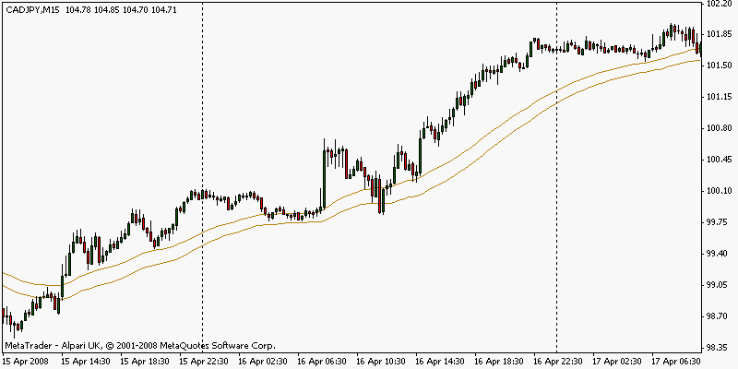

This is our line in the sand. Or two lines in the sand! The 50emas are very good at keeping us out of trouble. The first law of trading is to preserve capital so we can fight another day. The 50’s help us to do this perfectly by keeping us on the RIGHT side of the market for our TF.

You can see that if you are long the market then price needs to remain above the 50 emaH, (50 ema of the highs). The reverse is true for shorting the market. Price must remain below the 50 emaL. Acting on this statement alone will save us lots of pennies.

You can also see that if we enter a long position and price retraces to close inside the 50 channels, then we may exit with a small loss. This is one way of controlling our risk and keeping losses to a minimum. We’ll discuss this in greater detail later. For the moment, we are just setting up our charts.
In the nice up trend on the chart below, notice that there are very few opportunities to go short. Our system is already beginning to keep us on the right side of the tracks and we’ve only just started! Here’s the GBPCHF 15m again.

CHART #5
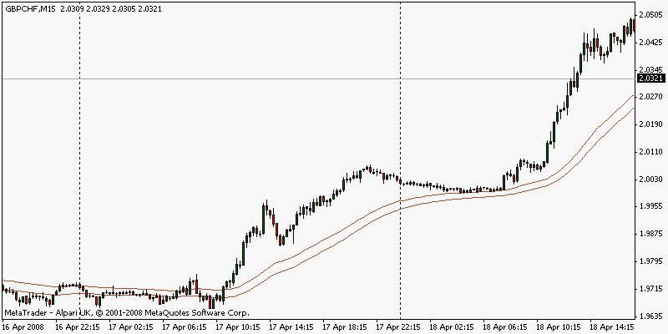

Here again, the 50’s keep us on the right side of the market. They do a pretty good job of preventing us making rash half-assed trades. This is a part of the grand plan to stop us overtrading (re: list). Don’t worry, should we have cause to exit because of our exit strategy only for the market to continue on its merry way, we can always re-enter on the next signal. We will discuss these signals shortly. In the meantime, let’s look at another chart. Check out the moves on this 15m cable, GBPUSD.

CHART #6
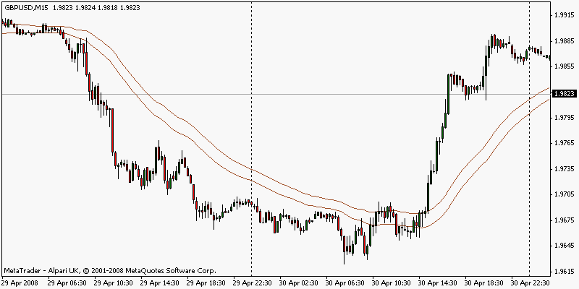

The chances are very good that we will lose money if we trade the opposite to what the 50’s say. Not always, but more often than not. An example being; we enter a long position when price is below the 50’s. Believe me, there will be more than enough trading opportunities for you without going against the grain or trend, so we really don’t want to risk it. Agreed?
Agreed!

For our purposes, and for the TF we are trading:

If price is above the 50’s then it is in an up trend.
Similarly, if price is below the 50’s then we have a downtrend.

This is only a general observation but it has certainly kept me out of many duff trades and continues to do so. We have other confirming indicators to add later that will tell us the direction we should place our trades but nevertheless, the 50’s are a good, quick indication of trend that should not be ignored. The Black Dogs (in the next chapter) together with the 50s, form a much stronger indication of trend direction.

What about when the market is flat and in a trading range? Well, we have a way around that too. The BD system can’t beat the trading range every time, no system can. Before very long you will realize how good this is.

The 50’s are also instrumental in our entry criteria; the whole system is, in fact, built around them. That alone makes it important to understand the concepts in this section. Please read again. We could actually state a rule at this juncture about trading on the correct side of the 50’s, but we’ll leave it for the moment.
We have just begun the process of building our charts and already they keep us with the mini-trend (one of the items on our list). This concept is doubly reinforced later and selects for us the high-probability trades much sought after.
For those who prefer the H4 TF, here’s the GBPJPY.

CHART #7
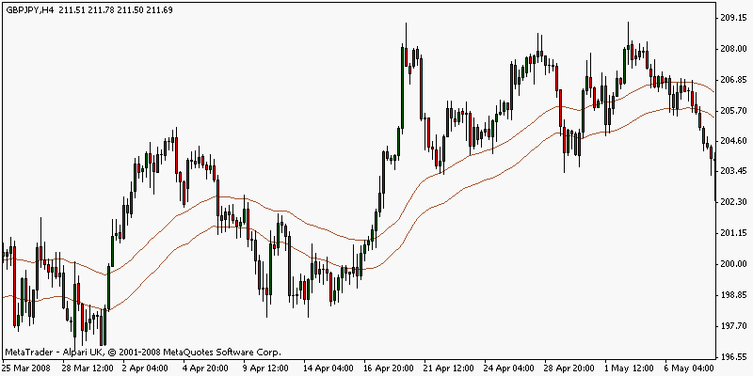

Notice how the 50’s keep us on the right side of the market.
Now, it really does depend on where your entry price is but the BD system will not allow losses to become astronomical. We have to accept losses as part of the business of trading; there is just no way to avoid them so the plan is to keep them tolerable. The rules keep us safe in this respect so it is worth repeating that it is folly to ignore the BD trading rules.

If the system says out ….. it means OUT.

We have had a single chapter on the 50emas because they are so important, the whole system is built around them so its worth spending a little extra time and maybe reading the chapter again. There is nothing difficult to understand in the entire system but its well worth waiting until all the concepts are ingrained into your trading memory before risking your cash. We will come to the exit rules shortly, let’s continue with our charts.

Edit 01.01.09: We now have the Color ma Indicator to replace the 50 ema's. The colour-coding assists in defining the trends. Of course, if you prefer to use the standard Metatrader ema's, that is fine. Chart 7a shows how the Color ma's change colour when they change direction. At this point, a visual aid only.
CHART #7a
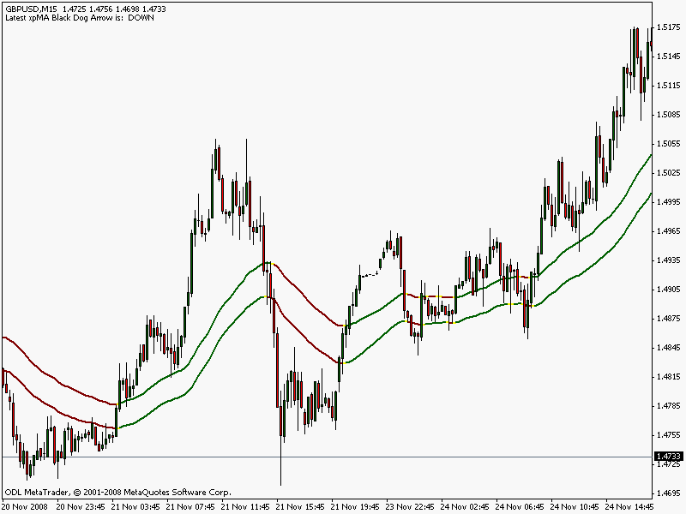

THE BLACK DOG AND THE S.E.S

5. Introducing the Black Dogs and the SES

The 50 ema’s are obviously not enough to base trades upon but they do keep us on the right side of the market nonetheless. For me, I need a little extra confirmation of this. What better than being on the right side of the market when a higher time frame is also on the same side of the market confirming the move? Sounds good.

For example, if our charts are showing a signal on the 15m TF AND on the H1 TF all on the one 15m chart, then the odds of success are greater. For the moment we'll concentrate on the higher TF signal that tells us ONLY the direction in which we are likely to trade, it does not tell us to enter the market.

By having arrows on the screen to tell us which direction to trade is a great help indeed, not to mention the audio alarm when they appear. More of this later. These higher TF signals are the famous Black Dogs, they correspond with our indicator that will be placed at the bottom of our trading screen in the next chapter. Consider chart #8 of the GBPUSD below:

CHART #8
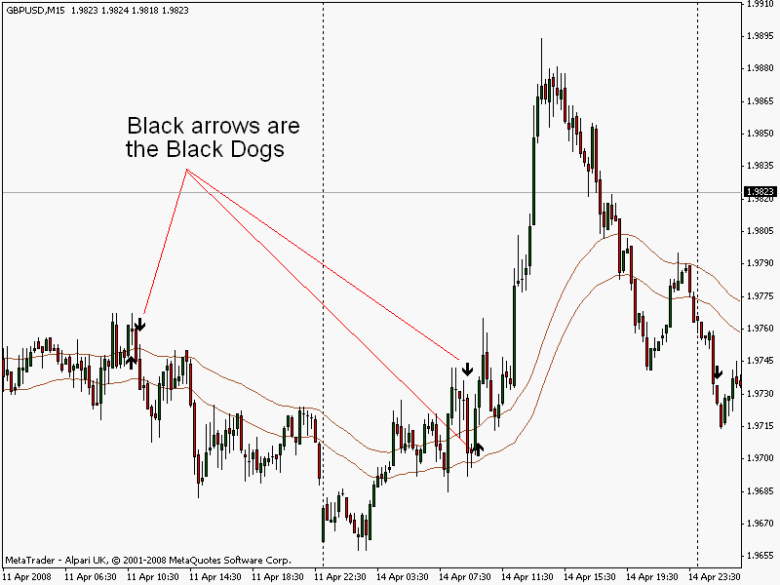

These arrows are the famous Black Dogs. They tell us what is happening on a time frame four times higher than the time frame we are looking at. These arrows correspond very closely with our indicator (to be added later).
For example, if we are looking at a 15m chart and a Black Dog appears, this tells us that the trend has changed on the one-hour TF.
Similarly, if we are looking at a H1 chart and a Black Dog appears, this tells us that the trend has changed on the H4 TF.

Simply multiply the timeframe you are looking at by four and this is the timeframe that the Black Dog refers to. This could not be simpler, it is very easy to understand. Multiplying by four tells you the BD trend! Simple. Here's another one; you are trading the 5m TF and a Black Dog appears. You now know that the trend has changed on the 20m TF.

We now have multi-timeframe (MTF) signals as per our list! If we trade on the right side of the 50’s AND follow the indications of the Black Dogs from the higher TF then …. WOW!

Looks promising, wouldn’t you say? But don’t start opening trades just yet, we are not finished with our charts. The Black Dogs are a signal when two Ema's cross. These ema's are 20 fast and 100 slow. Please use these numbers only. So, how do I get the Black Dogs onto my chart?
Simple, you must use the BD Crossover indicator which you can download from the MT4 CUSTOM INDICATORS at the top of the page. But please do not use the indicator just yet. Read on.

To recap on what we have so far. We have the 50 ema’s high and low to keep us on the right side of the market and we have the higher time frame Black Dogs set at 20/100 to direct us to trade in the correct direction. Therefore, we should only trade in the direction of the last Black Dog.

If you recall from the beginning of this e-book I was talking about how the price moves very similar to waves. The age-old description of higher highs together with higher lows describing an up trend and how it rises in waves is very apt. The opposite is true for a downtrend with lower lows and lower highs. The Black Dog System is designed to catch those up or down thrusts in those waves. I think that it performs this task very well indeed.

CHART #9
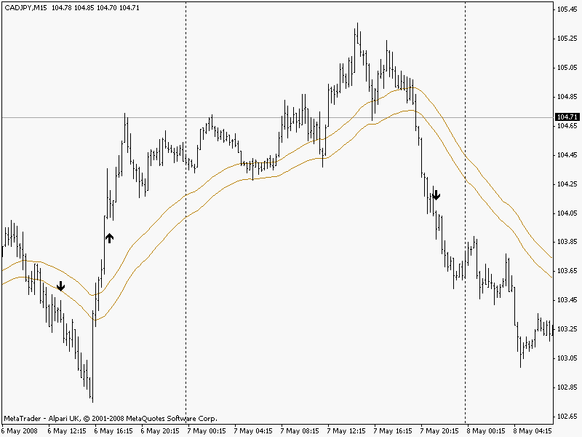

Now we’re getting somewhere. The Black Dogs together with the 50 emas produce a potent pairing for keeping our trades in the right direction. So far, if we stick to these two concepts, our trading should be fairly secure and any losses will be minimal. Things are beginning to look good. At this point we can now state our second very important rule:

Rule #2

If you must trade, then always trade in the direction indicated by the last Black Dog. No exceptions.

The above rule is so, so important. We only have two ‘written in red’ rules but please take note. This one will also save you lots of pennies.
Although we can enter trades using the Black Dogs, it’s not ideal for every occasion. Yes, it does tell us which way to trade, and even gives us an audio warning, but we’ll discuss Black Dog entries later. It is important to note from the previous two charts how the Black Dogs keep us away from the tops and bottoms, a very nasty place where all the money is lost, and I can prove it!
Up to this point we have nothing to show us when and where to enter the market, only the direction we should trade. We’ll consider this problem next.

The Standard Entry Signals (SES)

We have come to the point now where we need to fine-tune things just a little so that we can time our entries and hitch a ride on those waves mentioned earlier with a little more accuracy. Remember, the Black Dogs serve the purpose of informing us of the direction in which to place our trades. The Standard Entry Signals (SES) inform us that a trade may be imminent. That's all. The SES do not indicate entries into the market. Precise entry is discussed in a later chapter.

Our fine-tuning involves placing another ema crossover signal onto our charts utilising the same indicator as used to place the Black Dogs. This time our settings are 3 for the fast ema and 50 for the slow. The colours of these arrows are red for short entries, and blue for longs. We can place the Black Dogs AND the SES by using the same indicator, it is called The BD Crossover Indicator, the link is above. A chart of the GBPCHF will show perfectly how the shorter time frame signal arrows can get us into the trend (or riding those waves) by following the Black Dogs. These SES signals are my normal mode of entry; they are my ‘bread and butter’ trades.

CHART #10
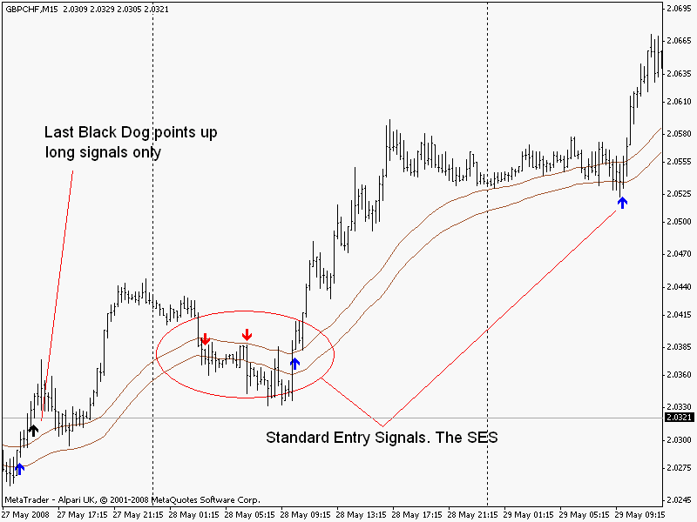

Notice how we would ignore the red ‘go short’ arrows on this chart because we trade only in the direction of the last Black Dog.

Please bear in mind that we do not enter the market merely on the appearance of an SES, we have specific entry criteria that we will learn about shortly. Remember, an audio alarm sounds when the SES appear, calling us to the computer to check if there MAY be a suitable trade. Then we can utilise our indicator, which we will place at the bottom of our charts in the next section. Using the SES and the indicator together provides more information enabling us to make a better judgement on our trades.

Up to this point we have the 50’s, and the Black Dogs, now we have the addition of the SES (with our indicator later) to direct us.

Also notice that we are trading on the correct side of the 50’s, and if we stay out of the market according to rule #1, then we enjoy some juicy moves on the GBPCHF. These set-ups occur very often on any number of currency pairs. Not every day, but usually. I have eight currency pairs open on my set up, which means I get plenty of decent signals. These pairs are:

EURJPY GBPUSD GBPCHF USDJPY GBPJPY EURUSD AUDUSD CADJPY

You may prefer other pairs, or the same pairs as above in addition to some of your own choice. It doesn’t really matter because you will get some great signals, I promise. Think about it, just one signal per day on each pair…

CHART #11
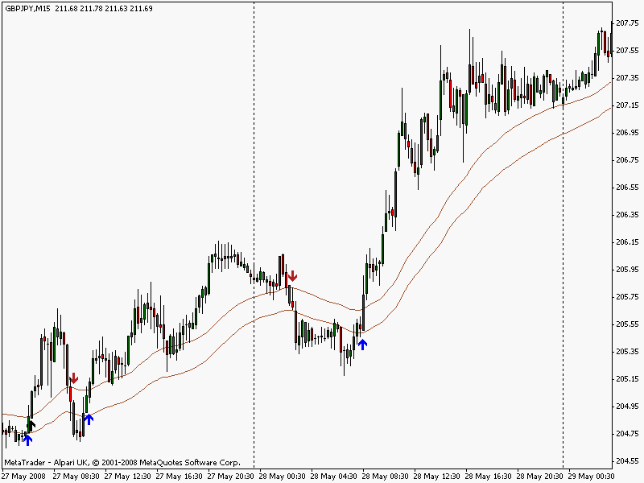

On the GBPJPY 15m above you can see the Black Dog to the far left and two excellent SES long signals. There was actually a third SES long signal on the 29th May at 10:30 that could have yielded over 100 pips! The Black Dog indicates only long trades and the three SES signals may turn out to be valid signals.
We will only know if the signals are valid upon checking our indicator, which we can add to our charts in the next chapter.

Unfortunately, I often have to ignore signals as I can manage only three or four trades at one time. But that‘s my problem. Yours is to learn this method and start microlot trading as soon as possible. Personally, I would avoid demo trading as all emotion is negated. Even trading for a single penny per pip will keep you enthusiastic. Then start profiting from a 'real' account as your confidence grows. This is an excellent system.

Download the BD Crossover indicator here

After correctly downloading the indicators you should close Metatrader and then re-open for the changes to take effect. Open the Navigator window in MetaTrader, this will reveal indicator lists. Scroll down to the Custom Indicators and right click on the BD Crossover and select ‘Attach to chart’.

In the ‘Inputs’ tab, the values should read, (from top down), 3, 50, 20, 100. The box for SoundON should read ‘true’.

The Colours are already set for you, but if you fancy a change you need to double double click on any colour then select the colour of your choice. Black for the Black Dogs! Click OK. The signal arrows are now on your charts; if not, then e-mail me and we’ll get it sorted out as soon as we can.

This is simply an exponential moving average crossover signal but only showing the arrow signals with an audio alarm, and not the ema lines. The audio alarm is priceless, it really is. You may set the colour for the Black Dogs to whatever you wish and, of course, you do not have to colour them black. Needless to say, on my trading charts, they are black.

I now challenge you, with your chart set up as described up to this point, to scroll back in time and see how accurate these SES entries can be. You must take into account our two golden trading rules. Not bad eh?

It’s important to understand that the SES signals always occur within the close vicinity of the 50’s. The Black Dogs also are not too far away. This means that any losses will not be too damaging should price rapidly reverse.

We have certainly satisfied our demands that were to stop us overtrading, and to keep us away from the tops and bottoms. We are also able to catch, or jump into, the mini-trends. In fact, we have nearly satisfied all our demands. All we need to do at this point is to place those Black Dogs and the SES onto our charts.

It’s probably best now to have a quick recap of what we have so far. See if you can answer the following questions?

We have the 50’s. Please describe them and their function.

We have the Black Dogs. What are they and what do they represent?

We have our two golden rules. What are they?

We also have the SES. A brief description would be lovely. Thank you.

It's a good idea to go with the flow and trade on the correct side of the 50's; the Black Dogs tell us the direction to trade; and the SES tell us that a trading opportunity is imminent. Ok so far? Good.

Please check back if you are unsure about ANY of the above. It is important that all aspects of the system are fully understood, simple though it is. Well, that’s it for the price window of our charts; we’ll now add the indicator at the bottom and we’re nearly done for our chart set-up. Even for the fairly accurate fine-tuned SES, I still prefer a little more confirmation for my entries when my hard-earned money is on the line, and so should you. So, let’s press on and get finished.
INDICATOR WINDOW

6. Indicator Window

Thus far, we have nearly completed our chart set-up, and we will talk about exact entries very soon. Next though, we have an indicator that will help with those entries and, most important of all, exits. I have to confess that exits have been the bane of my trading life. Entries? no problem. I have never had problems getting into a good move. The problems begin with when to take profits. Exiting too early or leaving it too late… that’s me.

Ok nearly there. Next we add the 'MACD with EMA' indicator to our charts. Download from the link above into the correct folder, the 'Indicators' folder. This is simply a standard MACD set to 10,20,1. The default setting is usually 12,26,9 and is easily altered in this charting package to our required setting. Alter colours to suit.

Download the Macd with EMA indicator here.

Chart below of the GBPCHF 15m shows the MACD without its EMA.

CHART #12
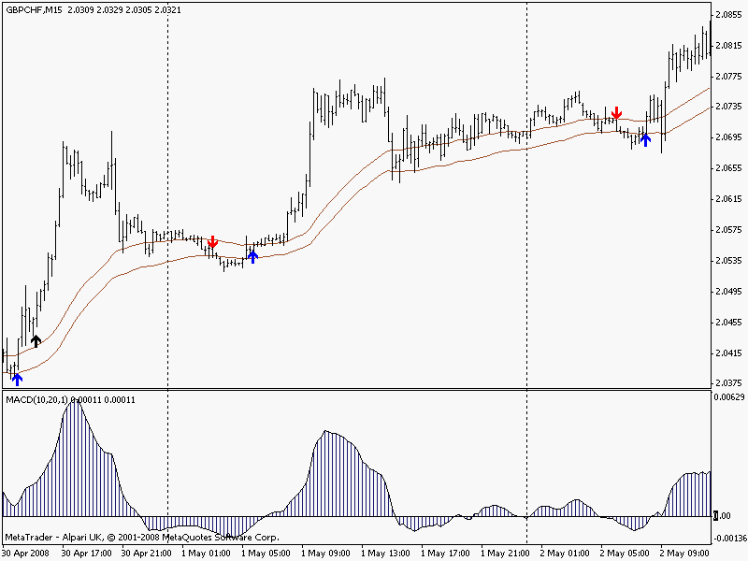

The interest we have in the MACD is primarily to confirm our entries i.e., it needs to be above its zero line for long entries, and below its zero line for short entries.
The crossings of the zero line should coincide roughly with the red, or blue arrows. If not, then no trade, and we must then wait for the MACD to cross to confirm the signal. Simplicity itself. So, on the GBPCHF 15m chart above,

a) The Black Dog indicates long trades only, (rule #2)
b) Wait for a blue long SES,
c) Wait for price to be above the 50’s,
d) Wait until after the London open, (rule #1)
e) Wait for the MACD to be above its zero line.

The MACD concept is so easy to grasp that I will not labour the point and show you chart after chart. Be sure to study the charts in subsequent chapters for the MACD in relation to its zero line.

Above zero = long, below zero = short. Easy.

And finally we have a little twist to help us with exits. This charting package allows us to place a moving average on an indicator. For our purposes we want a 7 ema of the MACD, not of the price. This is very important.

We now have an indicator that does all this for you. The 'MACD with EMA' indicator makes life much easier. Your charts should now resemble all those that follow. The chart below shows two entries using our final set-up.

CHART #13
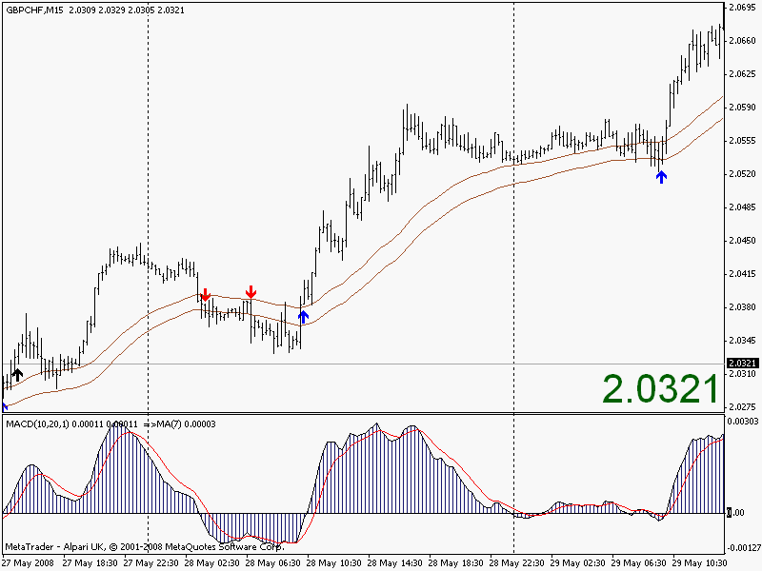

Chart #14 is exactly the same as my trading charts although I have the background colour slightly darker to ease the strain on the old eyes. A white background here is for ease of printing and saving on ink. I know the charts are not so easy to see but I have tried to get as much information as possible onto the screen. Your zoom facility will help. It often pays to zoom out and look at the big picture during your trading.

The chart above shows two consecutive days of profits on our old friend the GBPCHF. The two blue SES long arrows are textbook signals and occur frequently. More importantly, it shows how the 7 ema told me to close the trades before any profits evaporated (more later). Let’s have a close up of the same chart but showing the first trade. Below is a shot of my trading chart and I must confess to nearly always using candlesticks.
CHART #14
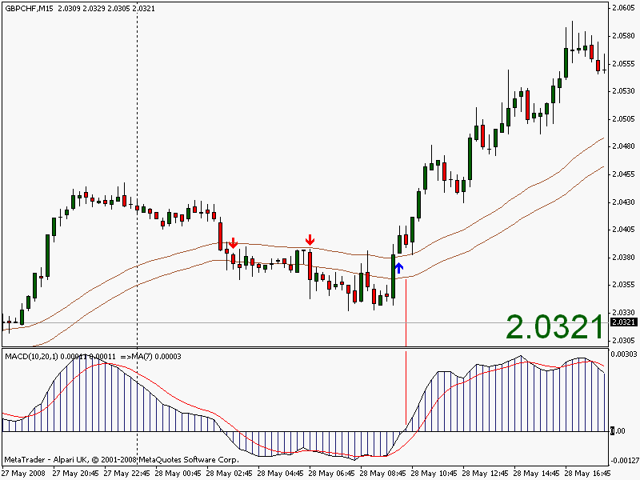

We’ve talked about quite a lot in the previous chapters, and you will probably think that there is too much to consider when a trading opportunity arises. But looking at these two charts I’m sure you will agree, and appreciate, how quickly you can make a trading decision.

Although this is a fairly new system, I’ve been trading the BD on a daily basis for quite some time and I would imagine that it takes me about ten seconds to make a trading decision. In, or stay out?!

Just to expand on the previous two paragraphs a little:

Rule #1 is easy enough. I start my trading at the same time every day, so this is easy to comply with. Similar for rule #2, we know where the last Black Dog is and if it points up or down. Therefore we wait for the SES alarm in the same direction, with the MACD confirming and price on the right side of the 50’s. That’s it in a nutshell!
Here’s another final set-up below showing the EURJPY 15m. Please take note of the Black Dog (unseen, but way to the left), the ‘flat’ trading hours, and the London open. Also note the MACD has slipped below zero and price has moved below the 50’s. This made for a very easy trade.

CHART #15
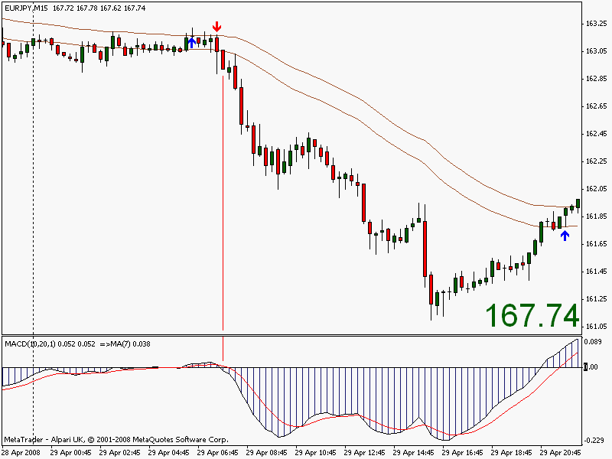

So, what exactly are the Black Dogs and how did you arrive at 20/100 emas?
This question is easy to answer. Remember our list that stated we require multi timeframe trading? Well, the Black Dogs indicate when the trend on the time frame four times higher has changed. The MACD is an excellent indicator to show trend. Now, the Black Dogs simply indicate when the MACD crosses its zero line on the higher timeframe. To verify this for yourself, on a 15m TF draw vertical lines at three or four Black Dogs then switch to a H1 TF. You will see that your vertical lines now show where the MACD has made those same crosses of its zero line! Simple. The SES simply ride the waves!
All we need now is the exact point of entry and, most important, where we will make our exit and take profits. ALL systems suffer losses at some point so we need to consider where we will position our stop loss too. We’ll discuss these points very soon. Next though, it’s entries.
ENTRIES

7. Entries

Trading is very easy. It’s showing a profit at the end that stymies most of us. As I mentioned earlier, I can get into good positions, I can make good entries, but knowing when to exit has caused me problems. The ‘exit’ part is for later. This system WILL get you those good entries if you adhere to the rules. The rules are there to stop you from overtrading (a killer), fishing for tops and bottoms (even worse), and to keep your cursor from the buy or sell button without good reason.

What have we got so far? Well, let me try and explain how I trade this set-up. First, I do not stare at the screen from London open to NY close, I let the audio alarms call me to the screen in my little office. I have the volume set on ‘high’, which is enough to be heard from another room, or the garden, whatever. Obviously we do not wish to annoy other people. When the Black Dog, or the SES arrows appear, the alarm calls me to the PC and I then follow the rules.

1. Trading times (Rule #1).
2. Am I trading in the direction of the last Black Dog? (Rule #2).
3. Is the MACD above/below its’ zero line?
4. Is price above/below the 50 emas?
5. Is the latest SES pointing the same as the last Black Dog?

If these conditions are met then I can consider entering 2 or 3 pips above the HIGH of the bar that closes above the 50 emaH for a long entry.

Or I can consider entering 2 or 3 pips below the LOW of the bar that closes below the 50 emaL for a short entry.

The reasoning behind this way of entry is to let the market come to us. Not us chasing the market. Should the market take out the high/low of our entry bar plus 2/3 pips, then this indicates in some small way that there is momentum in the move and suggesting that the chances are it will continue to move in our direction. Many times this has kept me out of flat trades. It’s good! Please use this 2/3 pip cushion; it does save you money, promise.

As long as we trade in the direction indicated by the last Black Dog, then we are, in effect, trading a timeframe four times higher. We are trading the 15 minute AND the 1 hour trend. Ok so far? Good. We’ll look at an example.

Referring to Chart #16 below, on this occasion there was an SES to the long side but price did not close above the 50’s. The last Black Dog indicated ‘long’. At this time the MACD is still below zero. It is now a waiting game.
The first close above the 50’s was bar (or candle) ‘A’ and we can refer to this as the ‘signal bar’. If bar ‘B’ takes out the high of bar ‘A’ plus two pips, and MACD is above zero, then the odds are in our favour. Occasionally they are not but that’s the nature of trading I’m afraid.

Immediately the signal bar closes we know our entry price.

That price is the high of the bar plus two pips for the USDJPY below. The entry price for this trade is therefore 104.93
We can either enter the trade manually by watching the screen with our finger on the trigger and wait until the market reaches our entry price by using ‘instant execution’. Or set a pending order with a buy stop set at our entry price then sit back, grab a coffee, and watch.
Bar ‘B’ is the entry bar.
CHART #16
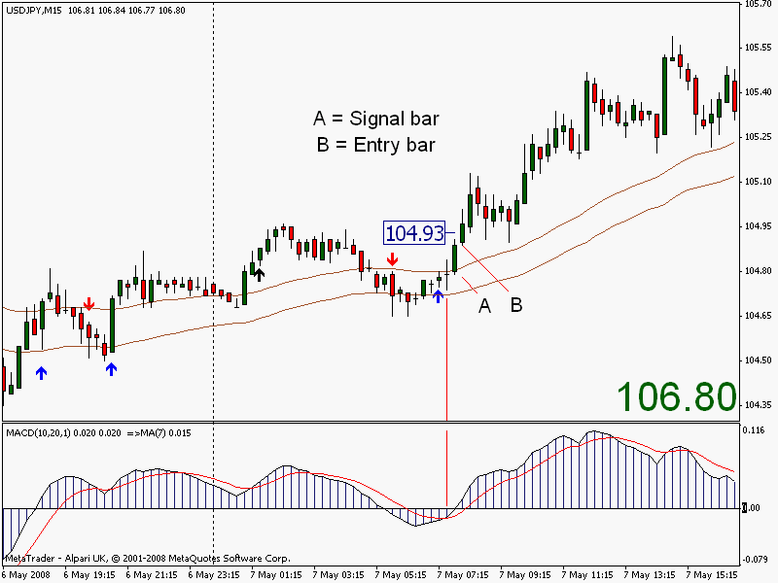

The Signal bar, or bar ‘A’, can also be the SES bar and is often the case.
Please remember, we are not looking for home runs with this system on a 15m TF. We want to get rich slowly. Hit and run tactics suit this well. Home runs are for the higher timeframes.
This chart is the previous trade. I’d like to zoom in a little more here so that you can see what is happening.
CHART #17
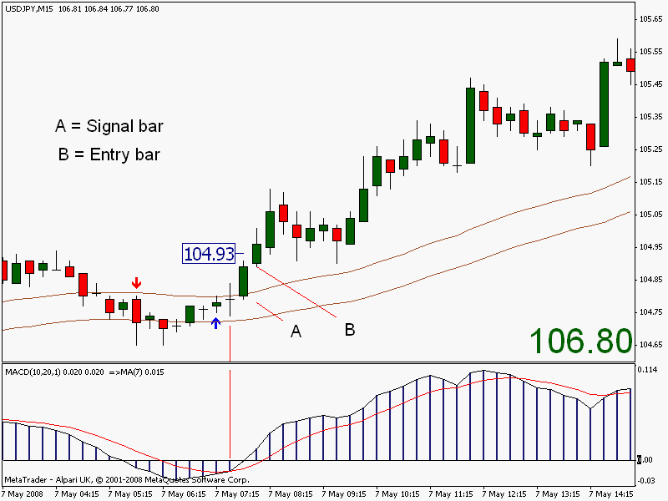

Please notice the following (again).
We are trading in agreement with the last Black Dog.
We are trading in agreement with the last SES.
We are entering on the high of a close above the 50’s.
MACD is above the zero line.
Please say to me, “Dave, that’s not too difficult to remember. It’s easy”.

So, which of the above is the more important? Is it the Black Dog? Is it the 50’s? What?

I look at it this way. When your hard-earned cash is on the line then they are all equally important. Why risk it? We’re looking for high-probability trades with as many of the odds in our favour as possible. Makes sense don’t you think? In forex trading you need an edge, don’t lose that edge by flaunting the rules, and making things more difficult than they already are.
Here’s another example, a short entry on the EURJPY.

CHART #18
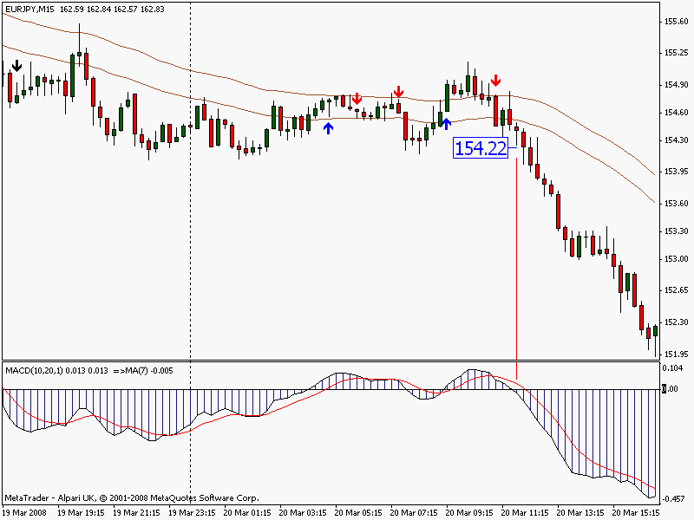

On this particular trade the Black Dog was way to the left and you can see that by ignoring the blue ‘buy’ arrows, and the ‘out of trading hours’ arrows, I was able to keep out of the market and avoid bad trades.
The alarm called me to the computer at the start of the 11:15 bar just as price retraced back into the 50’s channel by 35 pips or so. I was about to give up on the trade but I noticed the MACD falling and price did start to follow suit. I stayed at the computer until the signal bar formed allowing entry on the next bar. A beautiful trade followed.
I won’t insult your intelligence by showing example after example of ‘beautiful’ trades. We all know it is not like that in the real world. The system is very simple and easy to grasp. But, for the sake of completion, I will show a trade now that did turn against me. They happen and we have to live with ‘em.

I must stress this once again, don’t become disheartened after a losing trade, or even three or four in a row. It happens to the best of traders. The good traders don’t blame their system. It’s usually a flat market that causes the losses and it’s probably best to stay out for the day.

Shortly after 16:00 GMT on the 5th May the EURUSD gave an SES alarm closing above the 50’s and agreeing with the last Black Dog. The MACD was not yet above the zero line so I waited to see what happened. A down bar, followed by another higher close above the 50’s, led me to the conclusion that there were possibly rising prices ahead. The next up-bar would take the MACD into positive territory so I classed the present bar as the signal bar and that gave me an entry price of 1.5485.

All good so far, would you agree? Price then went a couple of pips in my favour, plus spread, and then quickly knifed me in the back, left me holding the baby, with egg on my face! Minus 25 pips later I was out. I had completely forgotten about the news announcement due out. Beware.
Without the news, prices would probably have meandered up for 20 pips or so resulting in another boring profitable trade! Makes life interesting I suppose.

CHART #19
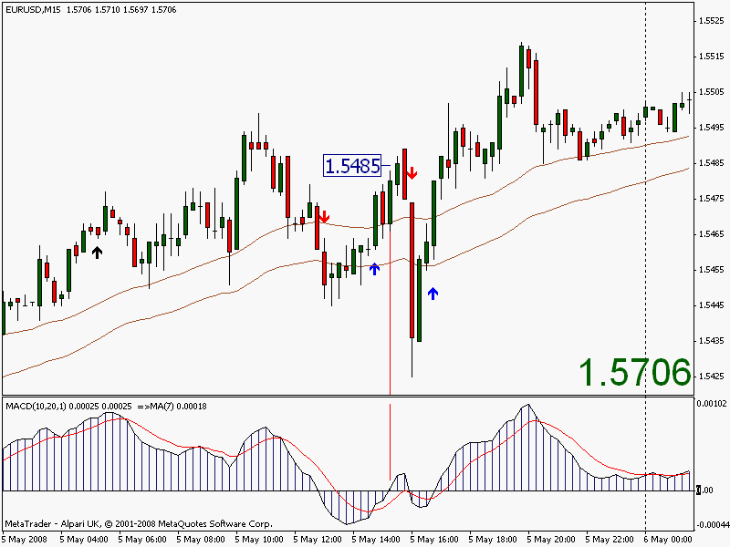

If we follow the rules EACH AND EVERY time then the odds, and our ‘edge’, will favour us over the long run. The trading gods will smile down upon us and all will be well with the world. This means discipline of course, discipline in sticking to the rules all the time. Discipline rules, ok!

The Black Dog Entry

This type of entry presents more risk. The trader with the more aggressive style of entry may prefer the Black Dog signals. I prefer the SES where the risk is minimised. This is different from the normal entry because, often, the Black Dogs are not so close to the 50’s channel. This is not to say that good opportunities are not there, because they are. Just a little riskier is all.

I like to imagine our charts this way; imagine the 50’s as a pathway where a man walks his dog. Now imagine the dog, at the end of a lead, sniffing his way all over the place, criss-crossing the path just like the price does. The dog always comes back to the path, especially when he gets too far away. Often, if he gets too far away too quickly, he comes running back. Dogs are unpredictable creatures especially during news announcements.

There are two ways we can enter after the appearance of a Black Dog.

The first is to enter when price breaches the last, or nearest, local high or low by 2/3 pips and then manage the trade accordingly. With these trades there is usually plenty of time to set up your pending order, your buy or sell stops, stop losses, and target prices, etc. the following chart shows an example of a trade taken on GBPUSD last month with a target price of 20 pips. Many more pips were on offer. Notice that all the rules were observed.

CHART #20
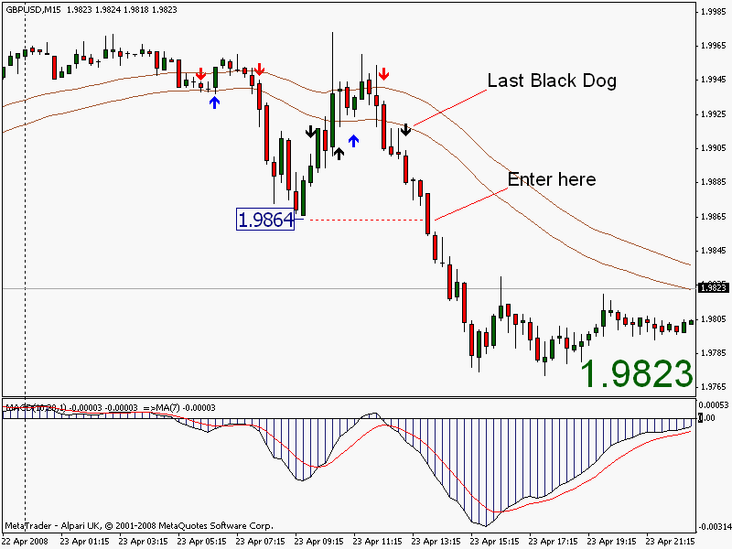

The second type of Black Dog entry occurs when there is no relatively local high or low to focus on. On this occasion it is best to wait for a slight pullback and then enter on the break of that high or low. The next chart shows this in detail on the GBPJPY.

CHART #21
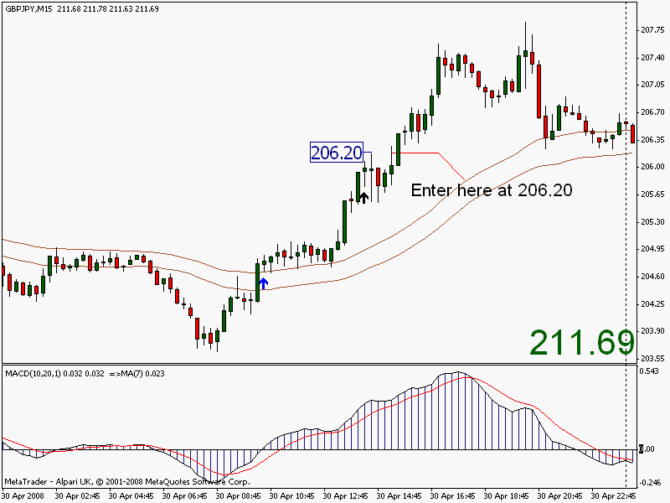

Again, all the rules were observed.

The truth be told, I really don’t bother with trend lines, support and resistance, pivots and the like. You know my thoughts on fibs. I don’t look for triangles, pennants, flags, or dodecahedrons, but I do have a soft spot for the head and shoulders and the challenge of finding one and trading it. My charts are as you see them and I do very well. I hate to have cluttered charts with glaring colours. I cannot sit staring at a Jackson Pollock.
Having said that, it’s worth noting on the Black Dog entry, that the last local low or high may be support, or resistance, or the first peak in a double top/bottom. Or maybe the left shoulder of that other famous pattern.

What I’m saying is … ‘take care, and be aware’.

I’ve found other ways of trading this system and I must discuss them with you; call me a softie, but I’ve found that trading the SES signals alone is all that I need to make a good living. Period.

MACD Entries

The best entries are with the red and the blue arrows (SES) as these are always close to the 50 channel, but quite often these are absent from some of the bigger moves. This does not mean that we have to stay out of that move; rather, we have to find different ways of entry. Enter the MACD with its own ema and this will do the trick nicely. Check out this chart of the EURUSD where a whole day passed without a signal arrow. The last Black Dog is just off screen to the far left.

CHART #22
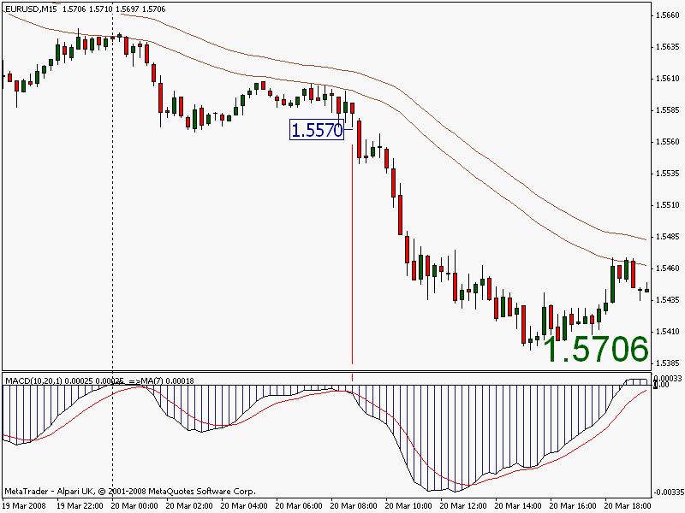

As long as we observe the rules, then we can’t go far wrong. Imagine though, if this trade went against us and suddenly turned north. By using the rules our losses would be minimal. This trade could have gained over a hundred pips using the MACD exit described below. A trailing stop would also have been very interesting. The same rules apply to long trades.

I must confess at this point that I usually miss this type of trade owing to the fact that there is no audio alarm to attract my attention. My loss!

The 50 ema channel looks pretty sweet on that chart. The idea being to find an entry that is fairly close to it so if price does turn against us we can take measures to bail out.

On that chart of the EURUSD above you can see that price is under the 50’s and coming down in waves. All is great in hindsight I hear you say, but following the rules of this system will get you profits.
For MACD entries: The last Black Dog points down, so we are looking for a close under the 50’s (but it has to be near to the 50’s). The MACD must be under its zero line, and preferably under its ema.

That’s it!

The odds of a successful trade are pretty high.

This is a very good indicator that we have at the bottom of our charts. Also, any time the MACD crosses its 7 ema, take heed. In the absence of an SES this would be a good shorting signal when the MACD crosses below the 7ema when both are below the zero line. Ditto for long signals when the MACD is above the zero line. Here’s one that occurred today on the GBPCHF yielding well over 150 pips!

CHART #23
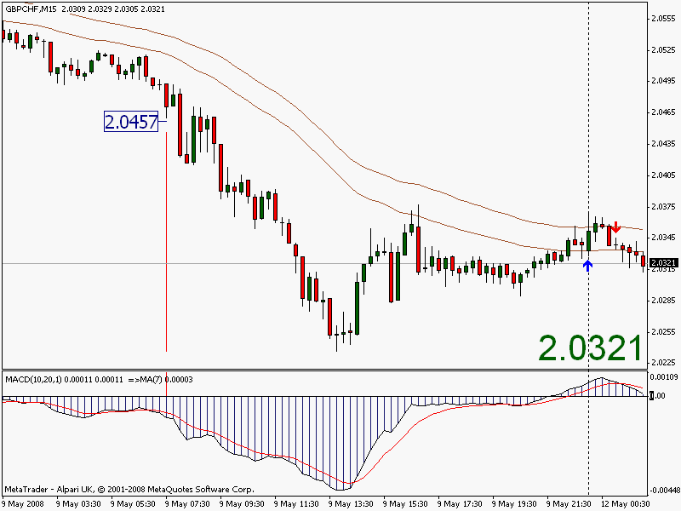

Sometimes these signals amaze even me!!!

The Hi/Lo Entry

I usually use this method on rainy days when I can’t get outside to the garden, or when we have guests in the house and I want to disappear to my office (only joking). It’s just a simple method of getting into those trends that have been missed for one reason or another. Or maybe just to pick up a quick ten pips or so. Try this on different time frames.
Remember, all our rules still apply. By our definition, if the last Black Dog points up, then price is in an up trend. Vice versa for down trend. Here’s a down trend example. All we look for in that downtrend is an up bar, or up candle. We look to enter at the LOW of that up bar. Chart please.

CHART #24
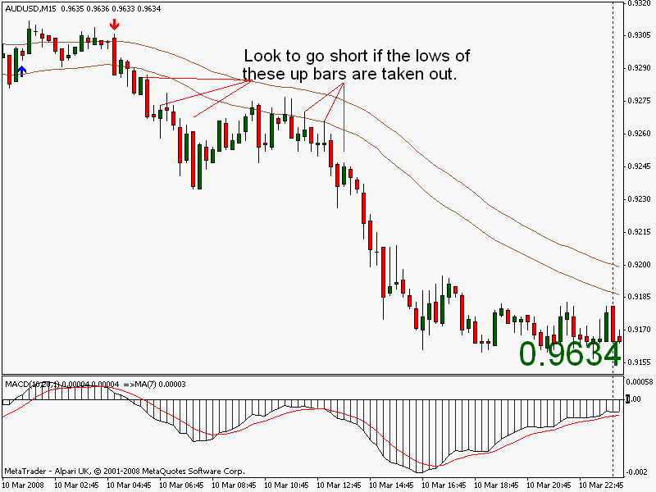

I haven’t put price boxes on all the entries here to keep the screen clear, nor have I shown all the entries, but I think it’s pretty clear. This method is not bad for scalping a few pips. For these short entries, notice how the moves are better if the MACD is below its ema.

There’s also a good example of more than one up candle in a downtrend here. If the first low isn’t taken out, then move onto the next higher low.

If we stick to our rules, ad nauseam, then we’re on pretty solid ground.

Carrying on with the same theme of the Hi/Lo entry, the following chart shows two entry points on the EURJPY 15m.
All our indicators point north! The last Black Dog; price above the 50’s; MACD above its zero line; MACD above its 7ema.

CHART #25
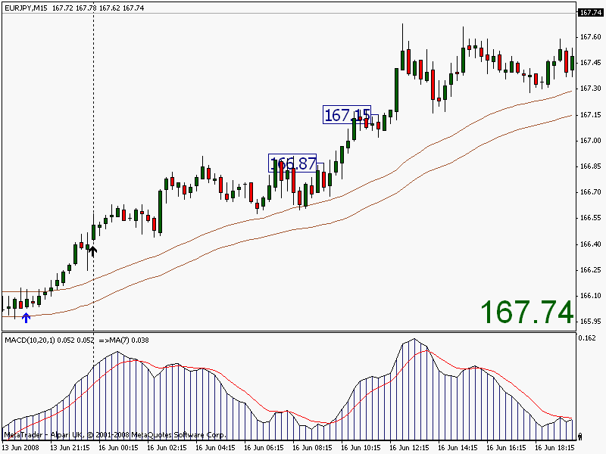

This is the optimum time to use this strategy; when the MACD is above its zero line and is crossing above its 7ema. Long scalps are possible with small profit targets.

The opposite is true for short scalping plays.

I tend to use the low of the entry bar as my stop loss if taking a long scalp thus risking only one bar’s worth of price action. On short scalps I would use the high of the entry bar as my stop loss.
Aim for ten pips or so on most pairs, maybe twenty on the GBPJPY and GBPCHF.

This is a good little strategy if you have missed an SES entry into a nice trend or during the times of a trend when there are no SES signals, as often occurs during long trends. I would also add that using this method on the higher timeframes looks to be a winner, especially the daily TF, but I confess to never having tried on any timeframe other than the 15m. I recommend it.

EXITS

8. At last we come to Exits

Stop Loss

Trading without a stop loss is like playing Russian roulette, before long you’ll get the bullet. It’s not for me to go into the ins and outs of money management. This is not the place. There’s plenty of information freely available on this subject.

We hear all this talk of the vast majority of new, and not so new, traders blowing account after account. Yes, I’ve done it. But now I know one of the main reasons why. It was because my head was chock-a-block full of so much useless information. Here’s one bit. I’ve never been an advocate of risk/reward ratios and all that bull. Why make trading more difficult than it is? The way I see it is; if you lower the risk then the rewards will come.

Why complicate it with RR ratios, Kelly values and all that utter drivel. Make your trading as simple as possible, an uncluttered screen; if you have tons of indicators then you are in serious trouble. The guy with four trading screens and 600 indicators doesn’t do any better than the guy with his little moving averages. Sorry, but it’s true. Again, rant over.

Different traders have different risk tolerances so where you place your stop loss is really up to you. What I can do is tell you where I place mine and why.

For a start, mine is called a Disaster Stop (DS) and is usually 50 pips, but not always. This is a small effort to avoid the stop hunters. A lot of traders like to place their stops slightly above the nearest high if short, or slightly below the nearest low if long. This is a well-known tactic giving the ‘guys with the money’ just the opportunity to hunt out your stops and close out your trades for a loss.

I watch my new trades like a hawk at the beginning and I know before long if they are turning against me, whereby I close the trade for a small loss. I can always re-enter. I like to move my stop to break-even as soon as possible (see Free Trade), usually after gaining 30 pips or so. Up to press, my DS has never been hit. This is not to say that I haven’t had losses, because I have, and lots of them. Thanks to this system they are small and the winners far outweigh the losers. If we can maintain that then things will be rosy indeed.

I must mention here that trailing stops are not a tool that I use and I am not familiar with the finer points. I cannot really comment on them as regards this strategy as we are aiming for short, sharp profits. We are not hoping to be in trades for any length of time. Two or three trades during the morning can give you anything up to 100 pips or so, leaving you free for the rest of the day. This is my preferred trading scenario … and I like it.

If you can make just a meager ten pips per day, every day, you will surely become filthy, stinking rich in time, and not too long at that. Just think about the truly awesome power of compounding.

Exits

On my early accounts, exits had been my Waterloo! I’d gain 30, 40, 50 pips and more just to watch them disappear as I hoped and begged the unforgiving market to turn back. No plan, no nothing! Read it and weep.

Let’s be honest here. I’m now at the point where I take a losing trade gracefully, I take it on the chin, but only if I followed the rules. A few losing trades are all part of the game. DO NOT let it affect your judgment. DO NOT try to ‘get back’ at the market. DO NOT look for revenge. It will only cost you in the end. The market will only hit back harder and without remorse. This is a lesson I learned very early.

Just trade normally and all will come to you. The occasions when I do rattle my cage are exactly the opposite. I haven’t followed the rules and lost. Examples of this could be; trying to anticipate the market or signals, trying to get in early, leaving trades on too long when everything says ‘close’. In fact, ignoring everything on the previous pages.

Thankfully I’m now well past that stage and trade responsibly, and with care.
So, how do we exit the market?

Well, the stop loss mentioned above is one way. The 50 DS.
Using a trailing stop is another.

Price reverses and closes within the 50 ema channel. (Discretion should be used here especially at the outset of a trade. I would certainly close if price entered the channel and popped out of the other side).

Or you could exit by using my preferred way. To preserve the majority of your profits consider using the MACD with its’ own 7 ema.

As usual, a chart is always the best way to show this.

CHART #27
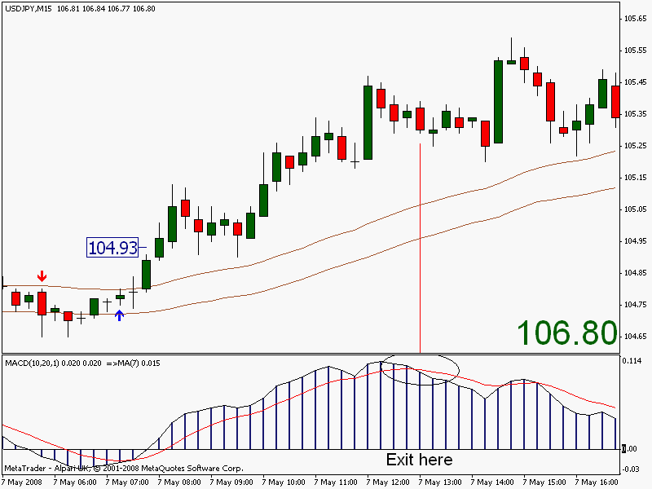

On the USDJPY above, you can see that a good long entry was made shortly after 07:00 GMT at 104.93. Price then moved nicely up to give, at one point, 50 pips to the good. Shortly after midday price fell a little causing the MACD to cross below its moving average (the 7 ema). The close of that bar is our exit point.

This is so simple a child could do it. So much so, that I don’t think there is any need for other examples. Just check back on your charts and notice how good this type of exit is. Scroll back quite some way and study the examples when you would probably have made a good entry into a trend using your preferred timeframe. See how the MACD/7ema would have produced a good exit point preserving the majority of your profits.

On your entry into the trade, the MACD will be above its ma. If not, then you should wait for it to be so. Exit the trade when the MACD crosses back over its ma. Nothing could be simpler.
I will not go further with this exit strategy, as it is fairly easy to grasp. It is the method I use. But, if I may waffle on for just a little while longer.

My unsuccessful years of trading did at least teach me some quirks of the market that occasionally stand me in good stead. Some of these I learned from a system taught by a well-known trader. Trading his system was my turning point. I have been using his strategy up ‘til recently, although I did want my own. You are reading and hopefully learning it now. It will not fail you I promise.

The above trade shows a long entry at 104.93. Normally I would not enter as the market approaches a ‘round number’ such as 105.00 as these can be stalling areas, if not resistance, the market has been known to completely reverse at these ‘round’ numbers. In fact, the market did temporarily stall for about an hour and became ‘flattish’. All our indicators said ‘long’, so ‘long’ it was. Additionally, as it was the first hour of the London open I felt that there was a good possibility of higher prices.

The point I am making here is to be aware of the fact that price could be approaching a resistance area at these numbers.

Another ‘quirk’ I often use is to exit at the close of a long bar. By long I mean roughly two or three times the length of those preceding it. There are two good examples in the chart above. I certainly would not enter on the high or low of a long bar. Yes, some good trades may be missed, but there will always be others coming along and not too far away at that. I prefer higher probability trades and to keep the profits rolling in.

Target Price (TP)

This is another favourite of mine. Hit and run guerrilla tactics. Smaller targets but easier to hit. If you want a higher percentage of wins then this is for you.

Now, exiting the market is an art, especially with a profit. It’s an art that I’m still working on very hard to master. It definitely is the weak point of my trading. Using the MACD to exit is my preferred method but it has one drawback; I have to stay at the screen and nurse the trade to completion. This could take hours. Usually I have no problem with this, but there are times when, e.g., let’s say four very strong signals appear almost simultaneously and I have a pressing engagement looming. What to do?

Well, setting a target price (TP) is a nice option. When you open your trade set your profit target or ‘take profit’ at whatever you desire. 10 pips per trade is a fairly common target for me, but on the big movers like the GBPJPY, GBPCHF and maybe the EURJPY, I’ll set it for thirty pips. Hit and run, in and out, look for the next one, Bob’s your uncle and Fanny’s your aunt. Of course, it goes without saying that all our rules must still be obeyed.

I think it’s fair to say that I use this TP option more in the summer months, as I like to make a little profit then do other things. Each to his own, I suppose.

The Free Trade
This is worth knowing. Briefly, make your trade in the normal way according to the rules, and when you are up, say, 20 pips, close half your position, move your stop to break even, and let the other half ride, effectively giving you a free trade.
You are already 20 pips to the good. Your stop is now at breakeven including spread. You cannot lose. Move your stop loss accordingly using various methods e.g., three bar stop, or use a trailing stop. Should price retrace and stop you out, no problem, as you are still in profit for the trade. On the other hand, price could continue in your direction for hundreds of pips giving you one of those trades that we all dream about. Try it.

The Aggressive Trader
I have tried this on a number of occasions with great success, unfortunately on a demo account, but you must be careful if you are going to use your live account. Again, the London and New York opens are the best times for this. You will have more smaller losing trades, but your winners will be bigger as you get into the nice moves at the start of the sessions that are not signalled by the Black Dogs.

Basically, all you do is ignore the Black Dogs and trade the SES signals with a close of price above or below the 50’s with MACD confirmation. On a choppy day it could be expensive but the trendy days more than make up for it. It all depends upon your trading style.

Remember also that our entry criteria must still be applied for ANY entry, i.e., 2 or 3 pips above the high that closes above the 50’s for a long. Vice versa for a short. This system stops me from overtrading, it keeps me from the tops and bottoms, it also directs me towards the trend (short term though it may be), it saves me a fistful of dollars. This entry criterion adds to that in keeping me out of quite a few flat trades. Please take note.

Me? Don’t call me chicken but I have not got the nerve to go against the Black Dogs which is, in effect, going against the trend. Conservative is my middle name!

AND FINALLY...

9. And Finally

The Black Dog system is very robust and you should have no trouble at all in the use of the system. Any time frame will provide very good signals for you and there will be plenty of trading opportunities using the other entry signals too. The great enemy 'patience' has to be conquered, as does 'greed' and 'discipline'. The means by which you can beat the market are on these pages, but you yourself will have to defeat your own 'enemies', the Black Dog systems cannot do that for you.

You should master the Black Dog system initially and become fully conversant with all its meanings, simple though they are. When you feel that you are at that stage, and you can consider yourself very able in its use, you should then move on to the Mini-trend Finder system. The MTFinder is equally as simple but with more frequent trading opportunities. The 'Black Dog entry', and the 'Hi/Lo entry', apply equally to the Mini-trend Finder system. You will then have two big guns to aim at the currency market! And with more to come.

Your chart set-up should have the following:
50 ema of the highs
50 ema of the lows
BD Crossover set to: FasterEMA1 = 3
SlowerEMA1 = 50
FasterEMA2 = 20
SlowerEMA2 = 100
MACD with EMA set to 10.20.1

Should you have any problems setting up your charts then e-mail me immediately. I prefer e-mail to ‘phone, it leaves me free to trade.

blackdogsystem@btinternet.com
Skype: blackdogdave
Chart #28
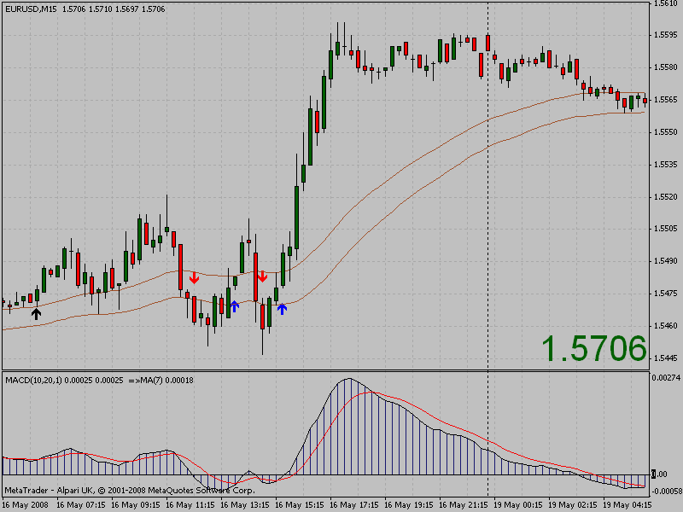
Chart #28 shows the final set-up and is my trading chart.

Please be aware of any major news announcements, avoid trading until the market settles down.

Rule #1

For intra-day trading on time frames under one hour, trade only from the London open until 18:00 GMT. Close all trades for the night.

Rule #2

If you must trade, then always trade in the direction indicated by the last Black Dog. No exceptions.

Remember our list at the beginning? Let’s see how we’ve fared in trying to satisfy those points.

Must trade with the trend
A chart set-up that is good for all currency pairs
A chart set-up good for all timeframes
A chart set-up that is simple, simple, simple
An audio alarm
Must stop me from overtrading
Must stop me from fishing for tops and bottoms
Must get me into the big moves of the day
Must keep losses to a minimum
Must tell me when to exit
Must be user-friendly
Must enable decision-making at a glance
Multi time-frame trading
Must give unambiguous entry signals
Do you think that this has been achieved?

From where I’m standing I would definitely say so. I have spent literally hundreds upon hundreds of chart hours looking at all possible combinations of this set-up along with possibly all known indicators to satisfy our list. The previous pages are the result of that. Please try to avoid making additions or alterations to this system as I am absolutely positive it will be detrimental to its’ performance.

It just leaves me to wish you peace, prosperity, and good fortune.

Dave Atkinson

PS Don't forget to read and digest the article in chapter 10. You'll be glad you did!

The next few pages show an article that has been published in various places from E-zine Articles to other less well-known sites. It is worth reading to enable you to construct your own set of trading rules. Please consider it as a template to get you started on the right path to trading success.

DAY TRADE FOREX SUCCESSFULLY
Set your rules out first

An Overview
So, you want to make big bucks trading the markets? We’ve heard all the stories of how fortunes were made in the time it takes to say, “where’s the keys to my Porsche?” But can it be done? Well – maybe. And you want a piece of the action, yes?

And I don’t blame you. Trading for a living, for me, is the best occupation there is. No boss, no overheads to speak of, work when you want, anywhere you want, freedom; just you, the computer, and your plan. Plan? What plan?

Of course, ‘plan’. Anything in life worth doing must have a plan of sorts. Trading is no different. In fact trading without a plan is asking for trouble of the most serious kind, financially speaking. You must have a plan. Read on.

The content of this very modest document has been the subject of many books, has been studied in depth by the very best of us, and will be debated for years to come. My aim here is to plant a seed that hopefully will steer you in the right direction thus saving you countless dollars, not to mention heartache and ruin.

Before you start to lay your hard-earned money on the line, there are many, MANY, things that need to be taken into consideration. The very first lesson to learn quickly is that the guys and gals who trade the markets for a living, the professionals, are not going to think twice about taking that money from you. They know all the tricks in the book, and a few more to boot. The idea is to act and think like those professionals and eventually become one. The profits will then begin to flow.

If you have no idea what you are doing, then you may as well just mail a cheque to those above-mentioned professionals and leave it at that, saving a lot of time. On the other hand, after losing ‘quite a bit’ in the markets, I copied them and you could do the same. Learn their tricks. In short, study, study some more, then continue studying. As they say, ‘knowledge is a powerful thing’.
Everything will then fall into place.

Where do I start?

Trading is very, very easy. Making a consistent profit is not - unless you have the plan we talked about earlier; a master plan. You need to learn, and sustain, some good habits. The primary weapon in your arsenal in fighting your opponents is getting the odds in your favour. Gaining an EDGE. Just like the casinos. Take a look at the house edge in the casino and how small it is. Something like 2.5%, this is enough to make them a fortune over time! It’s just the same with trading the forex markets, get yourself an ‘edge’.

Let’s stay with the casino example for a moment. They often have losing days when a punter will win big, but at the final reckoning; those boys will be in the money. And that is because of the ‘edge’. Your edge starts here. It’s not one item to concentrate on but your whole approach to trading. Sound complicated? Not really, when you break it down into its component parts. We’ll do this now with headings and sub-headings. There really is no point in doing this exercise if you only pay lip service to it. You must follow your rules because they will get you into the money, no argument.

Rules
There’s no point in having trading rules if you don’t follow them, which very nicely brings us to our only golden rule.

FOLLOW YOUR DEFINED RULES RIGIDLY
This rule may sound silly but think about it, how often do you break minor rules in some other pursuit such as driving, sport, work? Sometimes it can be costly, in forex it can be very expensive indeed, account-wise.
My forex rules are split into three sections, you may wish to do the same:

a) General - similar to laws
b) Trading - similar to regulations
c) System - well, rules when actually trading your system

Remember, this is a very short article on the ways that I have tackled the problem of gaining an edge in my trading, and in trying to emulate the professionals. This is by no means the only way, so you will need to address your trading traits in a similar manner to extract those profits from the market that we all aspire to. Let’s look at the general rules.

The reason you are reading this is because you want to make money. I have been in your shoes doing exactly the same thing, but at the wrong end of an £8,000 account. Yes, all gone! It wasn’t the first account that I had delivered to ‘the professionals’ so something HAD to be done. I made rules and divided them into sections, analysing them yet further. Here are my general rules that you may want to consider:

a) General rules

• Work/study hard continuously, knowledge is essential, but
• Strike a balance, have a life. Trading at all times will make you stale
• Take responsibility for every decision that affects your trading
• Self-belief in your aim, in what you are trying to achieve
• Do you want to trade full time or part time, how many hours per day?
• What IS your aim, what do you want to get out of it, know yourself?
• The only place where success comes before work is in the dictionary
• Treat trading as a business and organise it as such

A whole book could be devoted to just the above section, this article cannot delve too deeply into what only you can answer for yourself. Please take the time to write down your rules and how you will address them. Your trading will evolve for the better I assure you.

b) Trading rules

• What type of trader am I, do I want action, stress etc?
• Have a system that fits your trading style
• Become good at one style, tweak it to suit you
• Keep an open mind for each and every trade
• Do not form opinions on the market, let it tell you where it’s going
• Do not listen to the opinions of others
• The words ‘hope’ and ‘wish’ are not in your trading vocabulary
• Trade with money that is not indispensable, can you afford to lose it?
• Learn to take losses as part of the business, learn from them
• Take regular breaks from trading
• Don’t over commit yourself, not too many open positions
• Stand aside if you are not sure about a trade
• Do not add to losing positions
• Keep the dollar signs away, try to score points
• Without fail, have a trading plan and trade that plan

That last point in the list brings us to our final section in honing our trading skills, and making a living from trading the currency markets.

c) System rules

Most aspiring traders hope to win on every trade. This is just not possible and there will be losing trades. It is a fact of trading life. It should not be taken as a failing of your rules or system when these occur. Rather, it highlights how good your rules are in dealing with those losses. The aim is to win more than you lose by utilising the ‘edge’ described in the previous paragraphs. This ‘edge’ is gained by following your rules religiously, coupled with a trading system that suits your style. I have managed to do this after almost eleven years of trading and using many differing systems, styles, and techniques. We will add to your edge in this section. As a minimum your system should include:

• What time frame you will be trading
• The times not to trade
• Clear and unambiguous means of entry into the trade
• The reasons for entering and exiting the trade
• What your means of exiting the trade will be
• What size your stop loss should be
• Will you use trailing stops
• What position size will you use
• Dealing with news announcements?
• Will you scale out of the position etc. etc.

Each system has its own merits (or lack of) on dealing with the problems presented by the markets on a daily basis. Another example that I will mention is my own unwritten rule that I never trade on the first Friday of every month, this is when the NFP report is released and the markets tend to be a little too volatile for me. This is a lesson that I have learned the hard way (and I’ve paid for that lesson handsomely).
You can see, then, that your rules can evolve as your trading experience grows. You will also see that you will become more confident in your trading as you add rules to your overall trading system. Sometimes though these rules will be added after experiencing some drawback, or even a minor disaster, but this is all part of the learning process. You can bet your bottom dollar that the top traders amongst us have suffered a disaster or two along the way. The idea is to learn from those mistakes.

The trouble is that it’s difficult to learn a lesson by the written word alone. Some form of interaction is best in order to firmly plant that lesson into our brain. This is where experience comes in. But, I firmly believe that these pages will get you started on the right path.

My own system has very clear rules on the items mentioned above, plus many more, keeping me out of trouble when my money is on the line. Before I even pulled up a chart onto my computer, I started by asking myself what I actually wanted my new system to address by making a list. I already had most of the General, and Trading rules in place, in fact I have added to them fairly recently, but I wanted a whole new set of System rules. These are some of the items on my list that enabled me to build a new, easy to use, profitable system:

• First and foremost it must trade with the trend
• Must be good for all currency pairs
• Must be good for all time frames
• Must try to get me into the big moves of the day
• Must be user friendly
• Must be simple
• Must utilise more than one of my strategies on the same chart
• Must keep losses to a minimum
• Must enable decision-making at a glance
• I must be able to use aggressive/non-aggressive tactics
• Must have a higher time frame and trend confirmation
• Must have clear and unambiguous accurate entry signals
• Must also give clear re-entry signals into trends
• Must tell me when to exit
• Must have multi-timeframe trading on one chart
• Must give an audio alarm when signals are generated (important)
• Must stop me from overtrading (important)
• Must stop me from fishing for tops and bottoms (important)

Don’t take any part of this set-up lightly, as it will definitely pay dividends at a later stage of the whole process. The last two items on the list had cost me dearly in the past. The audio alarm is to call me to the computer when a trade presents itself, this way I do not need to stare at the screen all day. No more missed opportunities. Perfect.

The biggest task was to convert those ‘must haves’ into a working system that enabled me to trade for a (profitable) living. This has been achieved after no small amount of work, blood, sweat, and tears! In some small way, I hope that I have given you a base on which to build your own trading strategy. If you prefer to by-pass that final stage and use a system that has been created from the points listed above, then please drop by my website to view for yourself at http://www.blackdogsystem.co.uk

The website has plenty of free downloads. Don’t miss out. The Black Dog Trading Strategy goes from strength to strength.

I wish you all the luck in your trading endeavours.

Dave Atkinson
May 2008

COLOR MA

Placing the 'Color ma' indicator on our charts offers lots of advantages in helping with our trading decisions. Rather than just posting the indicator on here somewhere and letting people 'suss' it out for themselves, I thought that it would be better to say a few words on how I've been using it for the last month or so during the trial period.
First of all, what is the Color ma? Briefly, we hope it will replace the standard exponential moving average that we use for the 50s channel. You may continue using the emas if you prefer. I really would appreciate any pos/neg feedback so that I may pass them on to the whole group, or post your experiences with the new Color ma on to the forum .
Let's take a look at the indicator itself and then we can comment on it:

CHART #1 & 1a THE 50s & THE COLOR MA
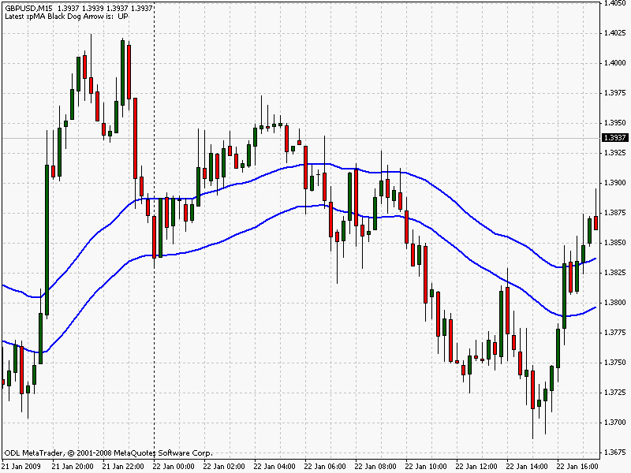
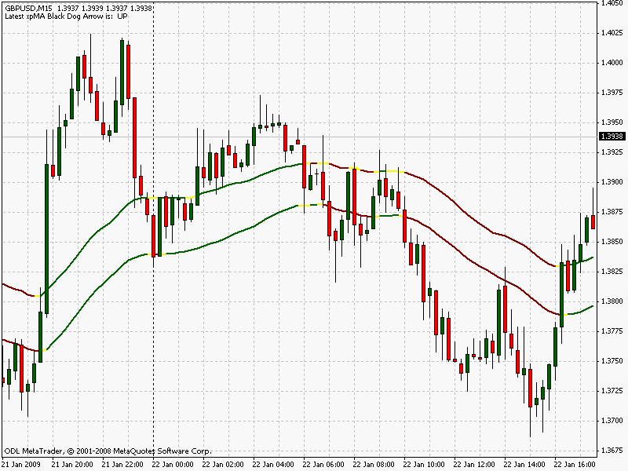

Chart #1 above shows the 50 ema of the highs, and 50 ema of the lows, as described in the Black Dog system text. Chart #1a shows the Color ma as I have it set on my charts. As you can see, there is no difference between them as regards the positioning, or where they are on the chart. The only difference, of course, is the colour. So we can safely substitute the Color mas for the 50s and use them with confidence in all situations as we have been doing. That's the first obstacle overcome.
Getting the Color ma onto your chart is easy enough. After you have downloaded all the indicators and templates from the MT4 CUSTOM INDICATORS page correctly (blue link at top of page) and into the correct folders, simply open a new chart > click on the templates tool button > select your template of choice. This will then change the blank chart to the correct set up; Black Dog or Mini-trend Finder. This is described fully on the forum in the DOWNLOADING INDICATORS section.
If you wish to attach the Color ma manually this is also quite simple. The correct parameters have been programmed in for you but the indicator must be applied to the chart twice. Once for the highs, and again for the lows. In the dialogue box which appears when you apply the indicator to the chart (shown below)select the 'Inputs' tab and make sure the values shown below are entered. To alter any value just highlight or double click on the number and enter your new value. It is important to note that the MA_Applied value is 3 for the lows, apply the indicator again to your chart and change the MA_Applied value to 2 for the highs.
I must also state that I have the 'Alert On' set to false as I only want my audio alarms to sound when an SES appears. Otherwise it can get a bit much.
MA_Period 00 = 0 50
MA_Type 0 = 0 1
MA_Applied 0ii= 0 2 (3 on second application)

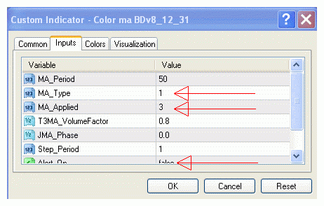

It must be said that if you are happy with the original 50s then stay with them. They have been in use with the BD system for a long time now with no problems. Now, it struck me that the change of colour could also denote a change of trend. Maybe. On chart #1a above it certainly looks the case. Let's add the xpMAs now and see how the two co-habit.

CHART #2 THE COLOR MAs AND THE XPMAs
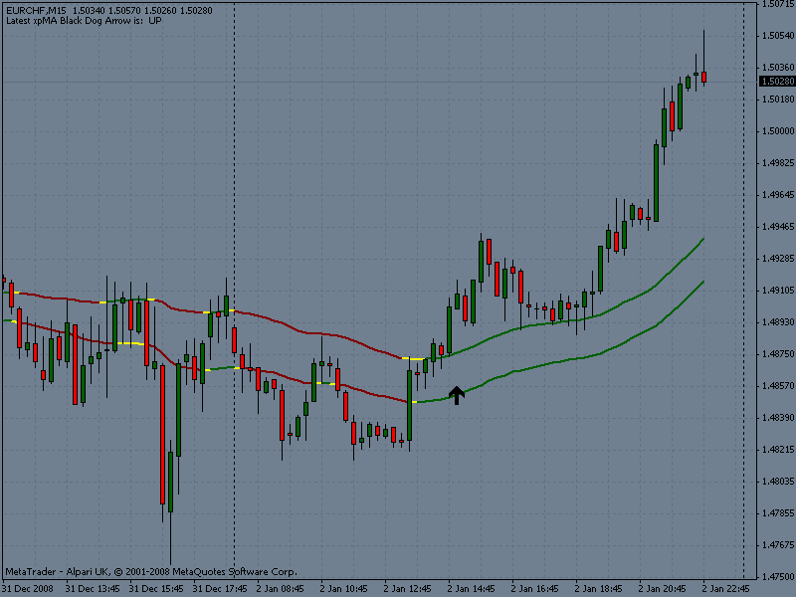

Notice how the Color ma, more often than not, changes colour at least one bar before the xpMA comes into play. This happens very frequently. Can we use this information?
Well, the xpMAs are slightly earlier than the original Black Dogs, now we have another indicator which gives us the nod slightly earlier still. To my mind that cannot be a bad thing. I know that I've said this before but you are going to have to scroll back on your charts to check that out. It will reinforce the idea into your 'trading brain' and anyway, it's always a good idea to check these things for yourself just to make sure that you fully understand the concept.

CHART #3 ADD THE RSI
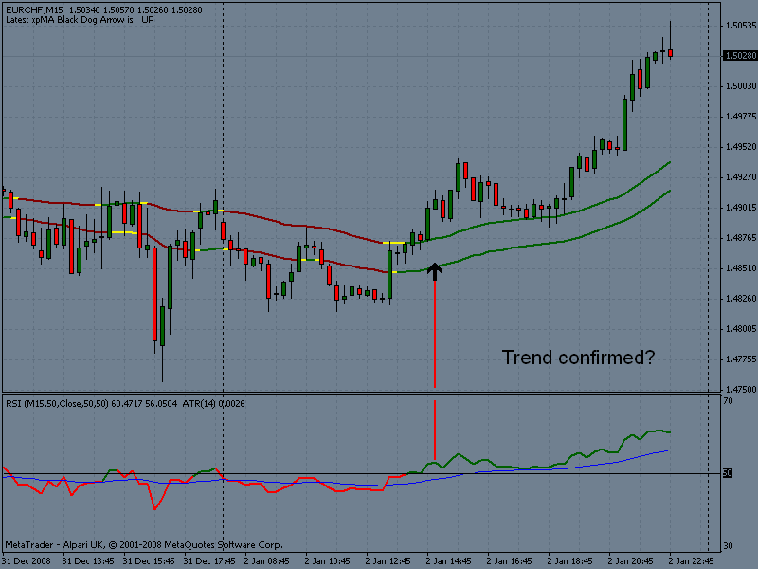

Now we can add the SES and the BidAsk price to the chart and we have lift off!
In chart #4 below, the last SES appeared when the Color mas were green, a good sign for a northerly trade!

CHART #4 THE FULL MINI-TREND FINDER WITH COLOR MAs
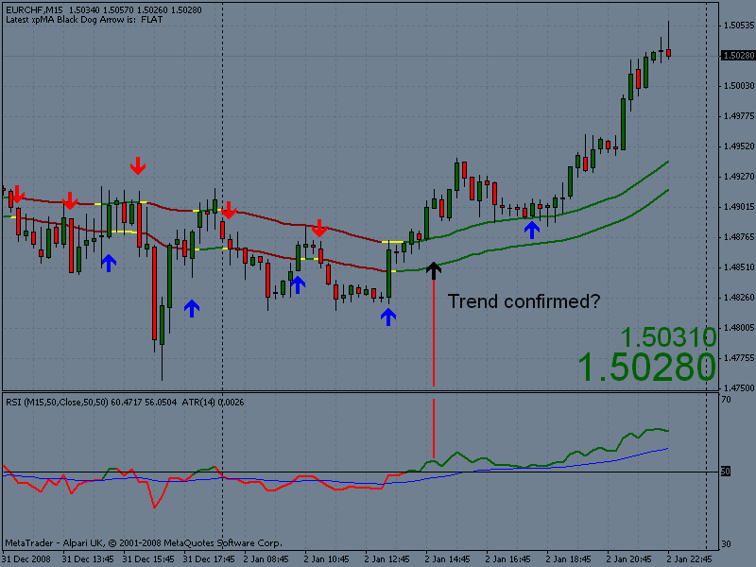

Notice that Alpari UK have gone onto the 5 decimal places from the 1st January. Not sure if I like that yet.

THE BLACK DOG MINI-TREND FINDER

You are going to love this system. It used to be my preferred way of trading time frames above the 15 minute timeframe but it is, nevertheless, good for that time frame. I use the Mini-trend Finder now for all my trading including the 5min TF as we shall soon see. As with all trading systems, you must have the discipline to trade it; this includes patience in waiting for the correct signals; no overtrading because the system will not allow it; discipline, discipline, discipline. If you want to succeed then you must have discipline. You must also have your list of trading rules, discussed in the article, together with the ability to enforce them. A good system with good rules plus a trader who can live by his trading rules equals a successful trader. No argument.
It is unfortunate that the two Black Dog systems cannot be combined into one although the Mini-trend Finder comes very close. In fact, it has coaxed me into trading the higher timeframes because of its success rate, which will be discussed later. The strength of the systems lie in their simplicity; and, as ever, it is the simple approach to trading that usually comes out on top. I beg you not to take 'simplicity' lightly but to take the time to find how powerful the systems are. It goes without saying that you should fully understand the workings of the BD system before reading further.
As the two systems are very closely related, I think it will be unavoidable that small parts of the Black Dog System will be reproduced here and, as such, I apologise in advance. I will not labour those points. So, where to begin?
Well, for a start, why another system?
Ok! At first ,we were trying to improve the BD but it seems that the optimal layout has been achieved, i.e., one size fits all, where there is no chopping and changing of parameters to suit different pairs. One template. Although stop sizes, trailing stops, and profit targets may differ. But it occurred to the BD team that owners of the Black Dog system would not see their trading suffer in any way if a secondary system were to be introduced that indicated the mini trends in a more distinct fashion. MetaTrader allows the possibility of flipping between the two systems to confirm each other, to show both systems on the same screen, or to trade each system in its own right. NEITHER SYSTEM IS BETTER THAN THE OTHER. The original Black Dog system is more 'relaxed' in its signals, whereas with the Mini-trend Finder there is a little more action and the trades become a little more frequent.
This secondary system, or BD Mini-trend Finder, is free anyway. It gives great signals. It gives the BD trader a choice of two powerful systems. So, why not?
Enough of the fluff. Let's get straight down to it.
In explaining the system, I'll use the same chart until we have completed the set-up then show a few examples to reinforce the concept of the Mini-trend Finder (referred to as MtF from here on in). First, let's set up our charts. Please start with a naked chart.

CHART #1 SOME EXCELLENT MOVES ON THE EURJPY 15min
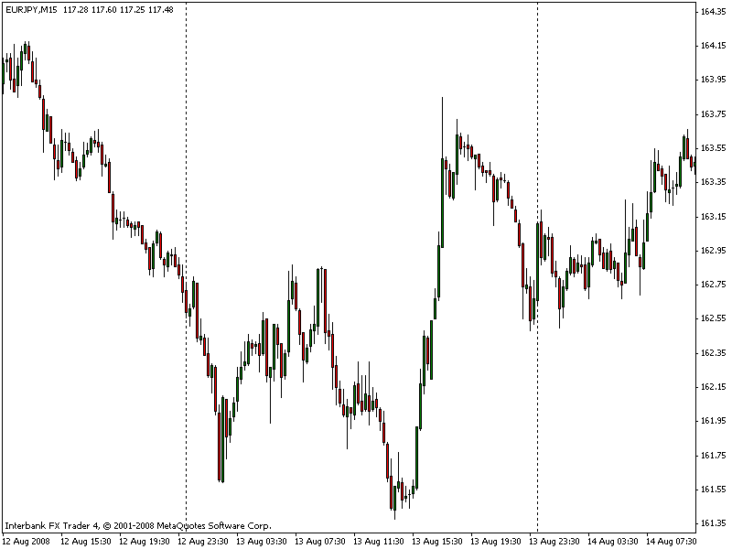

The EURJPY in chart #1 is on the 15 minute time frame which is my favourite, but please check out your favourite time frame and you will find that the BD MF will tell you the trend direction for the short term. There are some whopping moves on this chart and it would be nice to get in at the bottom and ride to the top, and vice versa. Unfortunately, this involves a great deal of risk in trying to find those entries and not many traders can do it on a regular basis. To trade in a safe and less risky manner we, as Black Dog traders, don't even think about trying to find those tops or bottoms but aim to profit by jumping into an established trend and waiting for our system to tell us when to exit.
Obviously, your profit target on a 60 minute time frame will be larger than that of a 15 minute time frame. Likewise your profit targets for the 4 hour and Daily time frames will be larger still. As with the Black Dog system, we still utilise the 50 ema's. (We now have a colour coded moving average for this task - the Color MA indicator). That is, 50 ema of the highs, and 50 ema of the lows as shown in chart number 2. Now, knowing that you are fully conversant with the original Black Dog system!... a full explanation of the use of the 50's is not required. Suffice it to say that we only trade long positions if the price bars are above the 50emaH; and we only trade short positions if the price bars are below the 50emaL. This is not strictly the case with the M-tFinder and the 50's are only on the chart as a visual guide. Nevertheless, this guide is very important in keeping us on the right side of the market as seen by studying chart #2.

CHART #2 THE 50's. A VISUAL GUIDE ONLY
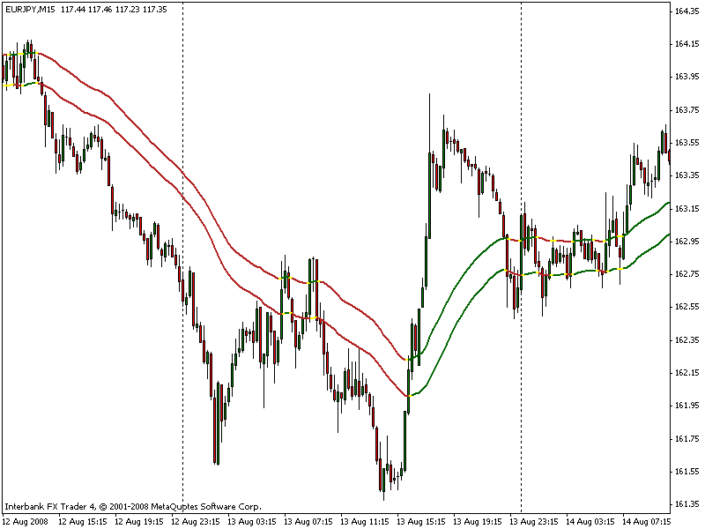

A very good indicator to show the mini trend is the xpma originally developed by Codersguru and is downloadable into the MetaTrader charts. The xpma does a fine job of highlighting the trends for us. If the colour of the xpma is green then we should only think about taking trades to the long side. And opposite for when the xpma is red, we should be looking to enter when we receive sell signals. It can be assumed that the black arrows are referred to as Black Dogs. Should you wish, an audio alarm is built into the xpma to let you know that the short term trend has changed, ie, when a black arrow appears. The default setting of the xpma has the alarm set to 'false', ie, deactivated. For you to receive the audio signal, simply change the setting from 'false' to 'true'.
In long, sustained trends a Black Dog may not appear for two or three days whereby the last Black Dog may not be on your visible chart. The comment in the top, left-hand corner is to verify the direction for you without scrolling back. This comment takes one or two bars to 'right itself' when a new Black Dog does appear, but this new arrow is visible on your screen and should be the one which dictates your trade direction, not the comment.

CHART #3 THE XPMA INDICATOR
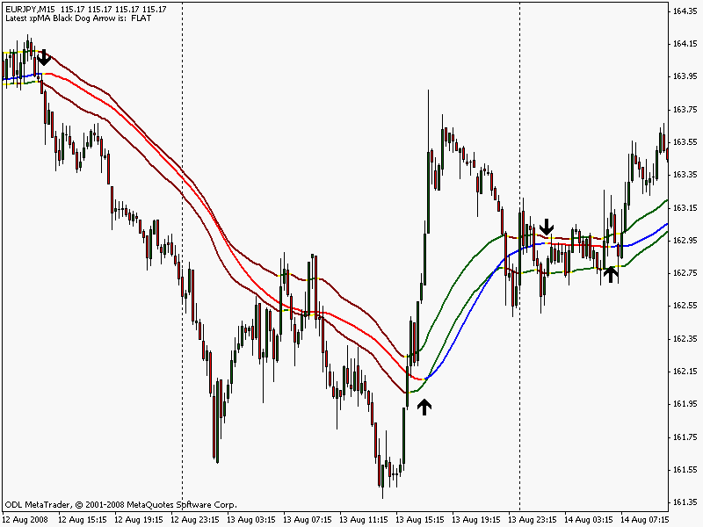

Download the Xpma and other indicators here.
The settings for the xpma are as follows:
MA Period = 25; MA Type = 5; MA Applied = 0; T3MA Volume Factor = 0.8; JMA Phase = 0.0; Step Period = 1; Alert_On = false; DebugMode = false.
These settings should remain constant on all of your charts, the single line is similar to the 50'sH/L of the Black Dog system but the black arrows appear in different places, they are not the same as the original Black Dogs. But you should trade in the direction indicated by the last black arrow. This ensures that you are trading in the direction of the mini-trend.
The xpma makes our chart look a little congested already and the less we have on our chart the better. All we really need are the black arrows so its better to dispose of the xpma line by doing the following ; right click on the xpma indicator, click on xpma properties, click on the colour tab, and then set colours 0-2 to 'none' and colour 3 to 'Black'. Our chart now looks like chart #4 below.

CHART #4 THE 50EMA's AND THE XPMA BLACK DOGS
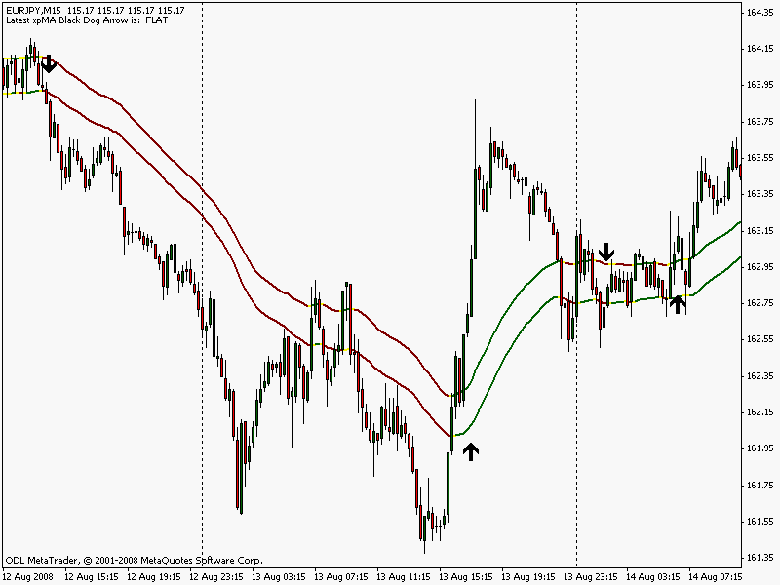

I hope that you are already beginning to see the value of the Mini-trend Finder. It is good! Scroll back on your chart as you have it set now and see how good it really is. There are some really excellent signals I think you will agree. To complete the price window of our charts we need to add another indicator. This is the 'EMA Cross (SES)' indicator which you can download from the link above. This time the settings are 2 for the FasterEMA, and 15 for the SlowerEMA. SoundON should be set to 'true'.

CHART #5 THE 2 & 15 ARE ADDED
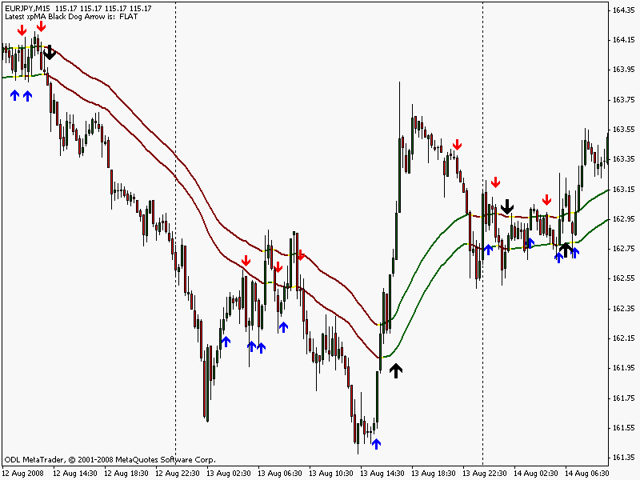

Don't be dismayed to see all those red and blue arrows. As with the Black Dog system, if the black arrow points down, then ignore the blue 'up' arrows, and vice versa. We'll discuss the significance of all the indicators shortly. In the meantime, we are setting up our charts. Once again, please scroll through your charts to appreciate the excellent signals generated by the black arrows and the red and blue arrows. Continuing with our chart set up, we can now place our indicator in the indicator window at the bottom of the screen as in chart #6 below. All our indicators come into play when a signal is generated so it important to have some sort of colour coding to enable speedy decision making.

CHART #6 THE 50 RSI
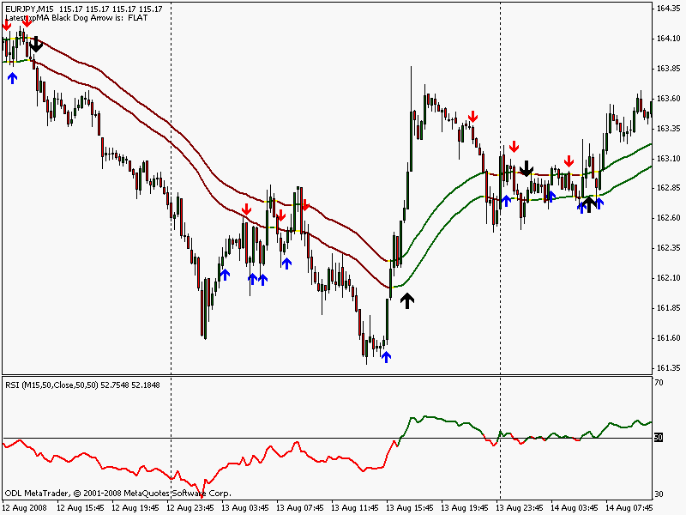

The Relative Strength Indicator (RSI) is a beautiful indicator and very suited to our purposes. The conditions of its use will be discussed very shortly but first we need to show the settings. After downloading the 'RSI BD' to your indicators folder, right click the indicator in the Custom Indicator list and select 'Attach to Chart'. Then click 'ok'. All the settings have been done for you.
Thats it. Now your RSI should resemble the one below. The blue line on the RSI is a 25ema and is used similar to the 7ema of the Black Dog system.

Download your RSI BD and other Indicators here.

CHART #7 THE FULL MONTY
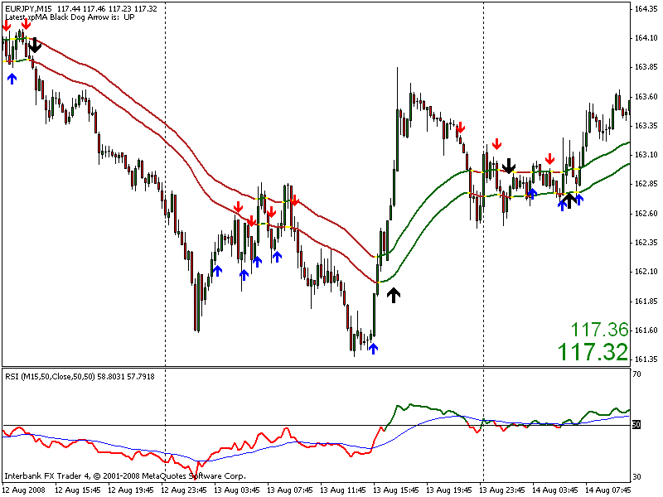

Your chart is now exactly the same as my trading chart. Except for the Bid Ask Price which we can now rectify.

Download the 'Bid_ Ask Price' and other indicators here.
You can now see the similarities to the Black Dog system. The xpma arrows define the mini trends nicely. On the next page we'll discuss how to enter and exit precisely and accurately, in fact, how to trade the Mini-trend Finder to its full potential.
MINI-TREND FINDER - Page 2

To be successful at trading, you need to treat it like a business, with steady growth and not hoping, wishing, praying, or pleading for the profits that you think you are entitled to. Nothing, repeat, nothing will come to you without the work and study time involved in your chosen niche. In forex you are entitled to nothing. Even with the Black Dog systems you will still have to work. Successful businesses grow steadily and this is what we want you to do. Your sales team, production team etc are in your head, your tools are the Black Dog systems. Learn everything about them and your business will grow steadily. You can even make your own rules to trade by (see Article) but make them you must. This is your edge in the markets. Good rules + good system = success.
The Mini-trend Finder is a good system so you are already half way to being successful, you must work on your rules yourself. A little more work and .... bingo!
The Article tells you how to set about making your rules. Here, we can complete one half of the equation and talk about the 'good system', the Black Dog Mini-trend Finder. Hopefully this will make the equation balance and success will follow.
I will continue to show the 15 minute timeframe as that is what we have become accustomed to in our descriptions. It must be said that the Mini-trend Finder can be traded on ANY timeframe. Should you decide to trade this system on the 15 minute TF then you should certainly follow rule #1 from the Black Dog system that states:

Rule #1
For intra-day trading on time frames under one hour, trade only from the London open until 18:00 GMT. Close all trades for the night.
For ALL time frames you should follow rule #2

Rule #2
If you must trade, then always trade in the direction indicated by the last Black Dog. No exceptions.
Again, these are our only two golden rules designed to save you lots of pennies. Sure, there are moves of a hundred pips or more that go against the Black Dogs, but by and large, the Black Dogs are good for the long run. On average it turns out to be the correct direction to trade.
Let's have a look at the latest charts and see what we can see.

CHART #8 CONFIRMING THE TREND
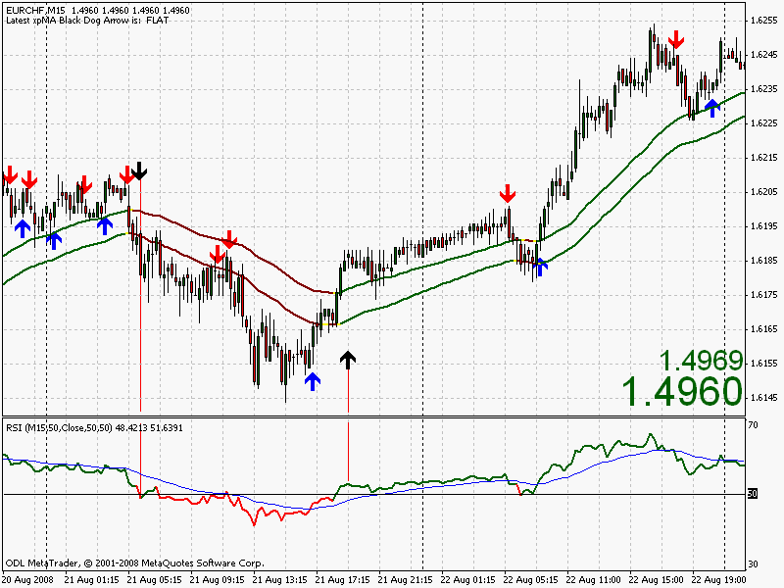

The EURCHF 15m above (Chart #8) shows close of play on the 22 August 2008. Also shown are two Black Dogs indicating the direction of the mini trend and also the direction of our trades. Before we start to open our trades we need to confirm the Black Dog Trend. The 50 period RSI must have crossed its 50 line (or changed colour) to confirm that trend. For example, the second BD is pointing north and the RSI is already green. This has, therefore, confirmed that the trend has begun to the long side. The same can be said for the first BD and, although there was a small retracement, price continued in a downward direction.
These are the mini trends that we seek, they MUST be confirmed by the RSI. The 50 ema of the highs and 50 ema of the lows are only visual aids but they also assist in helping us to confirm that trend. We'll look at one more chart to reinforce our understanding of mini trend confirmation then we'll move on to entries.

CHART #9 MORE CONFIRMATION
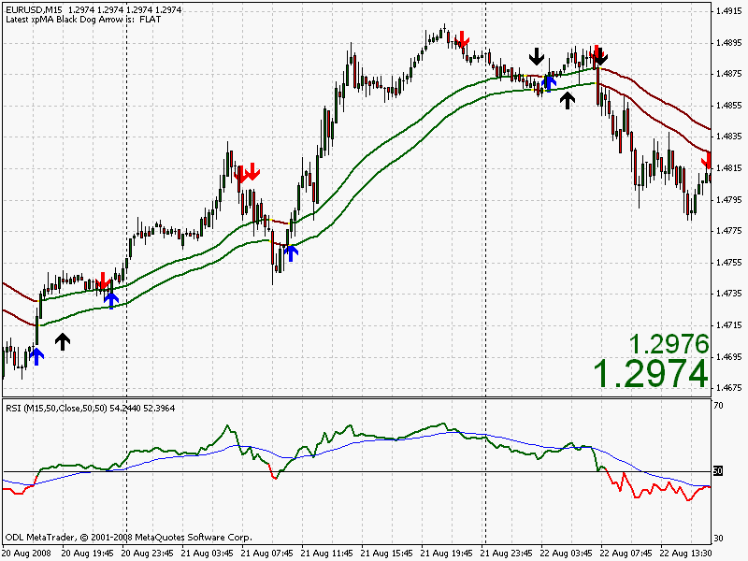

What do you deduce from the chart above? The first Black Dog has been confirmed by the RSI and turns out to be a good mini trend. The second BD is not confirmed by the RSI and the move fails. The third BD says to me that the trend is continuing, and the fourth BD is confirmed 2/3 bars later. Another interesting aspect is the Head and Shoulders chart formation which is one of my favourites, in fact my only favourite, and the fourth Black Dog is a nice indication of entry! Similarly with the chart below, there is a rough Head and Shoulders bottom and the Black Dog indicates nicely the break of the neck-line as does the RSI when it crosses the 50 line.
Please bear in mind that we do not enter on the Black Dogs. Their sole purpose is to identify mini trends that we can trade later. Entries are made simply by the use of the blue and red arrows. I can't resist showing one more chart, this time of the USDJPY.

CHART #10 TREND CONFIRMED?
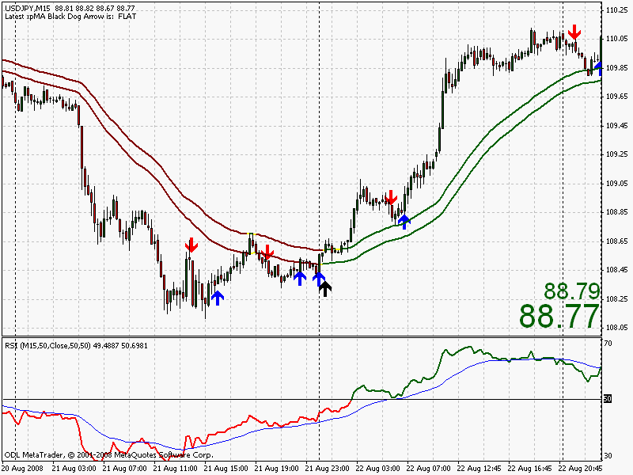

What more could we ask from our indicators? So, now we know how to identify the mini trends, how do we profit from them?
We wait for the audio alarms to tell us that a blue or red arrow has appeared and then we need to consider the following:
- does the red or blue arrow point in the same direction as the last Black Dog?
- has the trend been confirmed?
- for a blue arrow, the RSI must be ABOVE its 25ema.
- for a red arrow, the RSI must be BELOW its 25ema.
Enter 2 pips above the high of the signal bar for long positions. Enter 2 pips below the low of the signal bar for short positions.
I ask you again to scroll back through your charts of any pair to check out these entry criteria. Not bad eh?
Entering trades purely on the appearance of a Black Dog can be very risky indeed and I advise against it. Yes, some good trades may be missed but there are lots of good moves identified by the red and blue arrows that more than compensate. Best not to risk it!
Now here's an interesting scenario in the next chart. Look at the last BD, it has a blue arrow on the same bar. What to do? Personally I would trade it. We have price above the 50s. A BD pointing north. Confirmation from the RSI. The RSI is above its ema. Perfect.

CHART #11 DOUBLE ARROWS?
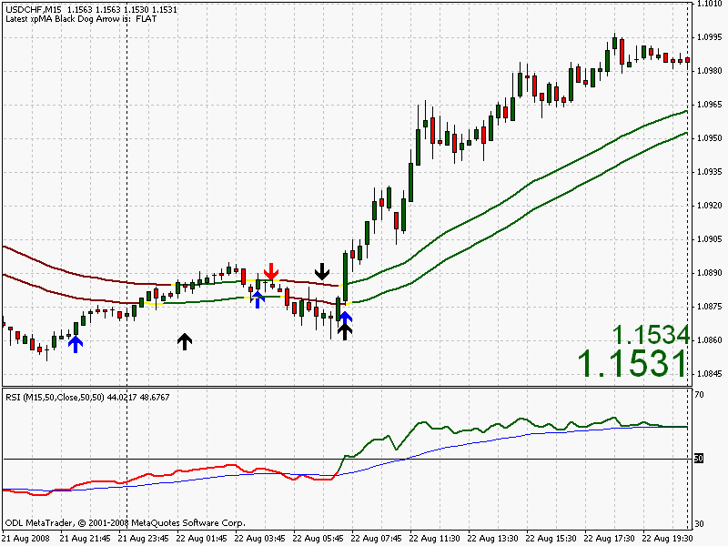

Trade to the rules and watch your profits soar. But remember, greed will also take care of your profits. So will patience, or lack of. So how do we manage the trades once we have entered?
As usual you can set a target price depending on the pair you are trading. This has got to be my most-used method simply because of the less time involved in the market. Less time in = less exposure to the foibles of the market. I just like to see those pips in the bank then go looking (listening!) for the next opportunity.
There is nothing to stop you trading the Free Trade scenario as mentioned in the Black Dog text. Perhaps I should try this more often as I do hit my 20 pip target quite regularly. It's that patience thing again, plus the fear of returning to my old days of regular losses I suppose. I really can't comment on the use of trailing stops as I use them very rarely in my hunt for those 20 pips or so.
It's worth noting that e.g., if the RSI is green, then we have an uptrend,and if it's red then we are in a down trend. These trends are all relative to the particular time frame we are looking at. We could be in a H4 uptrend, but a 15min downtrend. Nevertheless, please bear in mind that in our green uptrend, if the RSI crosses below its 25ema then the likelihood is a flat market tending to fall. Opposite for a red RSI, a flat market tending to rise. This is not a written-in-red rule but can give you an indication that things have ceased going our way for a while. It would be a good time to tighten stops or to even consider exiting the trade. In all events, it's a watch closely time as it could be a full-blown reversal.
Don't forget that with the Mini-trend Finder, we are only trading the red arrows if the RSI is red and preferably below, or crossing below, its 25ema.
We only trade the blue arrows if the RSI is green and preferably above, or crossing above, its 25ema.
The 50s are a guide only.
On the next page we'll discuss a cunning plan to extract those pips on a regular basis.

MINI TREND FINDER - Page 3

There's nothing wrong with making the normal entries as described on the previous page but for those of us who cannot afford a 1000 pip! stop loss on every trade we have to come up with other ways and means of extracting a living from the forex monster. As usual, and in an effort to uphold tradition, I will stay with the 15 min time frame. But this does not mean that you must trade this particular TF, on the contrary, you must trade the TF that you are comfortable with. The Mini-trend Finder will find good entries for you no matter what the TF is that you select.
To recap, if we are looking at the 15 min TF using the Black Dog system, then we are in effect trading the H1 TF but using the 15min TF to make our entries. The Mini-trend Finder is similar in this respect but the Black Dogs appear much earlier and, together with the xpma, confirms those mini trends that we seek. The SES, because of their make up, then proceed to identify the smaller pullbacks where we can make our entries.
''This is easy enough and we already know this''.
So, how can we make a decent number of pips without risking an awful lot in return? First, l must say that I do not like to cherry pick charts where it is all too easy to select the best chart formations and convey the message that this works every time. It doesn't, nothing works every time in forex but we know that don't we? Of course we do. Having said that I'm still going to pick the best ones but now at least you are aware of it, and anyway it's just to get the message across and then you can check your own charts. The xpma indicator arrows are not written in stone. They can, and do, disappear to appear on the next bar maybe. This is why we cannot use them for trading and making entries, but they are a good indication of a change of trend and produce an audio signal if required. The beauty of the xpma signal is that it appears earlier than the original Black Dog but still follows roughly the path of the 50 ema channel. The M-tF system is designed for those who prefer to trade more frequently, with earlier signals, and of course, quick profits.
There has been many times that as soon as I enter a trade, the damn thing moves against me and often hits my stop. It seems to wait for me to enter then turns around and goes the opposite way, waging a personal battle against my account. Do you find this? Is it waging a personal battle against a host of other accounts? I tend to think so! I have found that my win rate increases with an increase in stop size that allows the market to breathe and although I always start off a trade with the DS of 50, I don't want this on all trades all of the time. I also do not want to increase my stop size to any degree that will make trading not worth while. So, what to do?
Ok, the first thing to do is wait for a Black Dog to appear and then, using the Vertical Line tool-button which is located on the toolbar across the top of the chart, draw a vertical line through that bar as in the chart below. This is a personal choice but if the Black Dog points north then I make the colour of the vertical line blue. If south, then I make it red. Chart #12 shows these vertical lines on the EURJPY 15 min, my favourite pair. Looking at the market as a whole, this particular day in the forex market was pretty flat and most traders with an ounce of brain would have called it a day and gone fishing. But using the technique described below I managed to battle my way to 49 pips. As you can see in the chart below, most potential entries, as they close above or below the 50s, tend to reverse sharply and could hit your stop.

CHART #12 BLACK DOGS and VERTICAL LINES
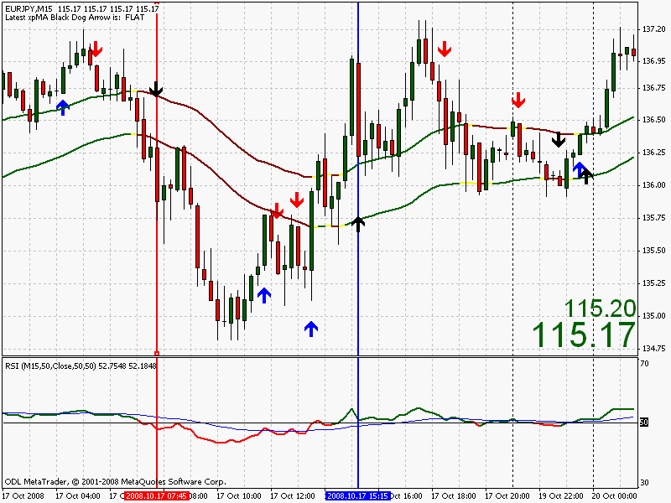

You can see that both trends have been confirmed as per our rules. Occasionally though, if the market drops fast and steep enough, there will be no SES for us to make our entry, but, instead of waiting for the next arrow to correspond with our Black Dog, i.e., pointing the same way so as to indicate a possible entry point, what you must do is to drop down a time frame. In our case which is the 15min, we drop down to the 5min. Let's look at the first Black Dog from our chart #12, the south-pointing red vertical line. Check chart #13 below. That vertical line will transfer to the lower time frame chart and we wait for an SES to indicate an entry point.

CHART #13 THE 5min EURJPY SHORT TRADE
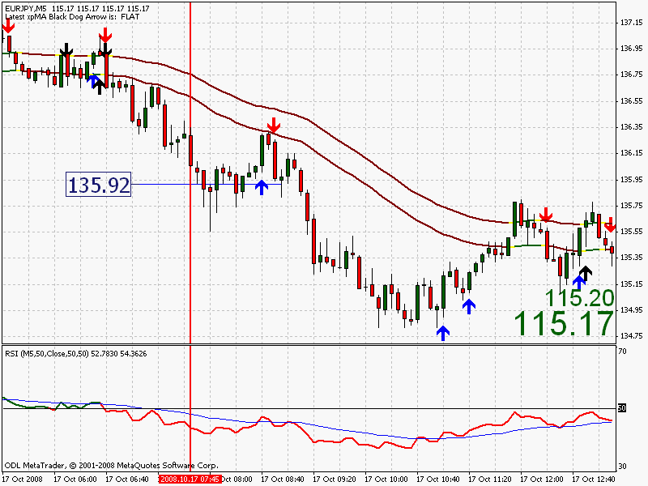

We look to enter at the low minus two pips on the next red SES. I have marked the entry point at 135.92. Mother Forex, being the indecisive so-and-so that she is, still contrived to go against the trade by 20 pips or so. (Please read the Stops & TPs blue link above). If you now check your own chart for this time period you will notice that there is another down SES signal to the far right of the chart. Personally I would not have taken this trade due to the RSI being above its 25ema. Even so, 20 pips were to be had.
Let's look at the other Black Dog on the EURJPY now, the one pointing north. Chart #14. Exactly the same, we wait for the next blue SES in this case, and enter on the high of that bar plus two pips. Easy enough.

CHART #14 5 min EURJPY LONG TRADE
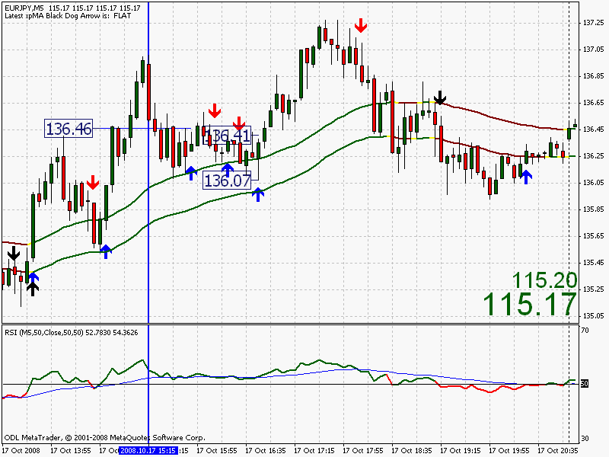

Or is it? The entry at 136.46 would most likely have been a loser, they happen. The low point came in at 136.07, a total of 42 pips to the downside including spread. Ouch!
The next signal high was not breached so no entry, the third SES at 136.41 finally got us in and we would have made some profit. These are volatile times in the forex market and a move similar to the one above on taking the first signal would, in more normal times, have been safely negotiated and profit made. Another point to note is that price remained above the 50s for most of that 'consolidation zone', and the RSI remained green, or above its centre line. The odds then (remember them) are that there are likely to be higher prices ahead.
Let's take one more example from the same day, which happened to be a relatively flat day considering the banking crisis of late. The EURCHF 15 min presented a good trade which unfortunately I wasn't part of. I was short the GBPCHF at this time.

CHART #15 EURCHF 15 min BLACK DOG & TREND CONFIRMATION
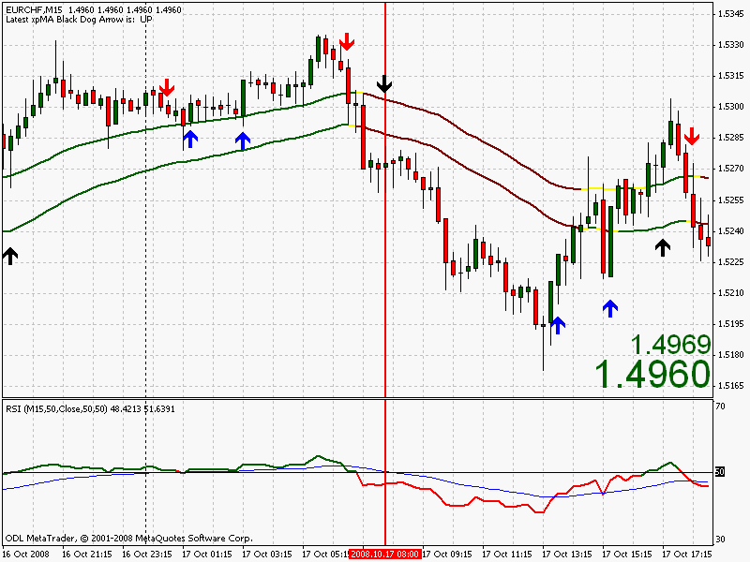

You could, if you were a trader of risky disposition, draw your vertical line when there is a close below the 50s and the RSI agrees. But I ask why? There are plenty of opportunities with this method. Lower your risk and keep the odds in your favour. Ok, we've drawn our vertical line so we can now drop down to the 5 min chart. The last two Black Dogs on this chart are outside my trading times. Here goes ...

CHART #16 EURCHF 5 min
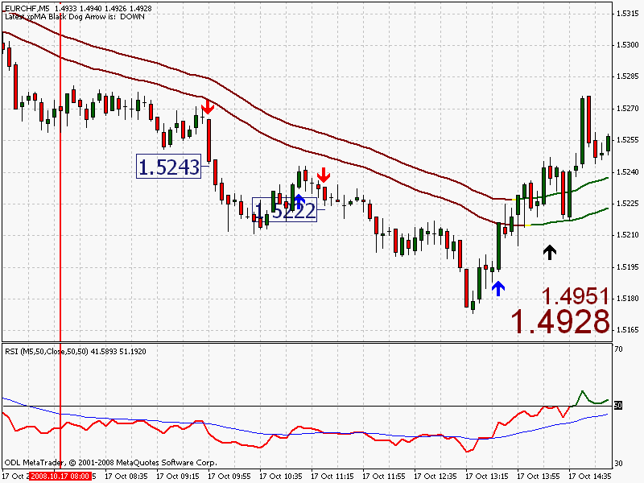

It would have been difficult not to have made your twenty on the first trade, the second is a little more complicated as a round number approaches. Possibly I would have settled for ten or maybe fifteen pips. The EURCHF definitely stuttered as it approached that round number of 1.5200. You may think different and stayed in for the duration therefore grabbing a few more pips. Horses for courses remember. It all depends upon your risk tolerance.
That should be enough examples to explain the entry. Your next question should be, '' For how long should I wait for signals on the 5m time frame? The trend may change on the 15m without me noticing.''
Good question. I nearly forgot to mention that. Simply wait for the next Black Dog and then revert back to your time frame of choice. Easy.
So Dave, what about stops and profit targets?
Another good question. Well, as regards profits, I aim for twenty usually but on the faster movers like the GBPJPY (in fact any of the more popular yens) and the GBPCHF, I try for fifty. I also try to not let a trade go against me after being in profit and close out for a small gain if it looks like reversing.
The blue link at the top of the page entitled STOPs & TPs goes further into setting your stops and profit targets so it's only repetition here. Better not waste time then, but as a rule, the opposite 50 ema to your trade can act as your trailing stop in the early part of your trade. It's not (usually) as high as the DS50 and can be altered manually at the close of each bar. See how you go.
MORE
I've got to say that I don't take much notice of all the usual sayings and cliches associated with trading in general, or forex in particular. 'Trade with the trend' is maybe an exception. It was mentioned in the Black Dog text about the rubbish that blocks your brain such as risk/reward ratios, Kelly values, Gann, Elliot waves, and the rest. How come the majority of traders lose at this game? Because everyone uses this tripe! It follows then that the wise man will not use them. This is not to say that you shouldn't, it's just that I have no place for them in my trading.
Everyone keeps saying KISS, KISS, KISS; simple is good, then they start talking about ratios! Geez! The market goes up and it comes down. Period. It can get a little more complicated than this, but not by much. I've also had lots of emails asking for statements for the last six months, well, I haven't really got the time or the inclination to muck about with those, I'm not a historian. What is the RR ratio? Who cares? I'm not a mathematician! Your aim should be not to lose. Make a profit everyday if possible. It doesn't matter what size that profit is. I'd rather watch my account grow than have the best pie-charts, spreadsheets, and graphs since my schooldays.
''Where should I place my stops?'' This has got to be the most asked question directed to me since the inauguration of the site. There is only one answer, ''where you think it will not get hit.'' This is a bit vague though to say the least, it could be taken to mean that you must place your stop hundreds of pips away! That just will not do, obviously, so we need to think of and devise other ways to protect our trades. Protection of those trades is paramount so the use of a stop should be mandatory for you. Please make it so.
Remember the first law of trading? Protect thy wad! Live to fight another day. Preservation of capital.
Again, upon entering a trade and as described in the Black Dog system, my initial thought is to protect my capital with a disaster stop of 50 pips (DS). Why 50? Well, using 15 min charts and watching a good few pairs, the signals can, and do, come thick and fast. A trade is entered and I then right click on that trade in the terminal window at the bottom of the screen and select ''Modify''. I have the 50 pip stop preset in the Modify stop box and click the ''Modify'' button. A 50 stop is placed within 3 seconds of the trade being entered. I can now look for other trades and follow the same procedure. I can alter the stops later at my leisure and place them at a more acceptable level when all trades have been entered and I am in the 'watch' mode.
What size stop is best? This is a big question and unfortunately one size does not fit all. Imagine a 20 pip stop on the EURUSD, it may be ok, but on the GBPJPY during the current crisis it wouldn't last 20 seconds! What we need to know is the range of each of the last few bars to give us an idea of how far the pair is moving. I say 'few bars' because we are trading on the 15 min chart and we will not be in the trade for too long, or for too many bars. This will be different for the longer time frames. There's no point in trading an H4 chart and aiming for 20 pips! Stops are bigger and so are the profits.
Working out the range of each of the few bars prior to entry! You either have to be a wiz at mental arithmetic, or a wiz on the old calculator. It would take too long and possibly be a tad risky if the trade had already been entered. Fortunately we have a tool to help that calculates the average range of any number of bars that we enter. The Average True Range indicator (ATR). Take a look at chart #1 below. The ATR is attached to the RSI window with a setting of 14 periods and the colour set to 'none'. I only want to see the value of the ATR.

CHART #1 THE ATR 14 period
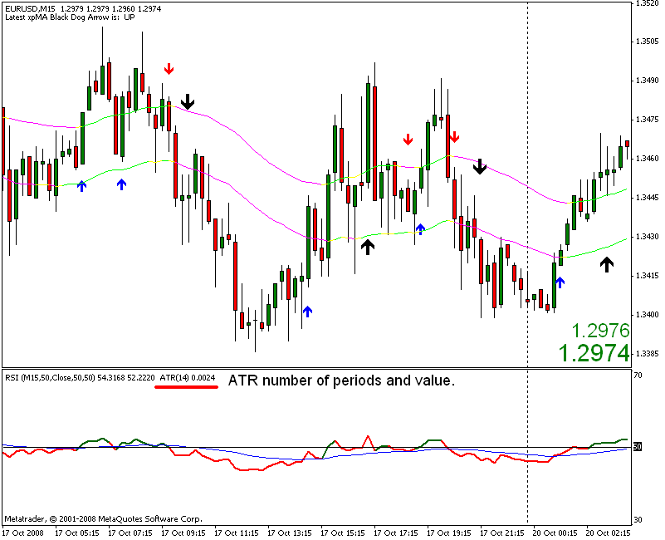

The ATR should be in both of your indicator lists in the Navigator window and saves you having to go through the download procedure. What does the ATR value tell us? The range of a bar is from the high point to the low point; the full range of that bar during the full 15 minutes, on a 15 min chart. So, adding all of the last fourteen bars together and dividing by fourteen gives the average value for each bar which, in our case on the EURUSD above, is 24 pips, at that moment in time. As the present bar is being formed, then the value will change slightly.
That means then that we can set our stop to 24 pips?
Not really, we need to give the Euro at least some leeway to move. To give it some elbow room. Personally, I like to multiply the ATR by 1.5 of its value to allow this elbow room. So you could set your stop now at 36 pips. Occasionally I multiply by 2 to arrive at my stop loss which in this case would be 48 pips.
The volatility of the market tells us the size of the stop that is less likely to get hit. How often is your stop hit and then the market turns back around and goes in your intended direction? Knowing the volatility and then adding 'a bit more' should make our stop compatible with the current market. Just to rephrase that last sentence; if the particular pair that you are trading is zig-zagging up and down at a rate of knots and possibly making 100 pip zigs and 80 pip zags, then a 20 pip stop will only cost you money, unless you are very lucky. It's all very well saying that you only use small stops but if they are getting hit all the time where is the sense in that. The other side of the coin is also true; why have a 50 pip stop if the market is flat-lining? Sure, you'll remain in the trade but you'll also be leaving yourself open to a large(ish) move against you. The ATR at least keeps us 'in tune' with what is happening NOW.
So, could we also use the ATR to help us with our profit target? Possibly.
Let's say that you use ATR x 2 as your stop. If you used ATR x 2 as your profit target then you would only need to win more than you lose to end up in profit. You could have any combination of ATR for your SL and TP. 1.5::2, or 1.5::3, or 2::2, or 2::2.5. It's all down to personal taste.
We could multiply the ATR value at trade entry by, say, 3 to give a realistic target. Multiplying by 2, 3, or even 4 would be quite a good guide. Anything above this would be asking a bit much.
There is of course the option of using the trailing stop function in Metatrader. I don't consider myself experienced enough in the use of trailing stops to give any insight and am just beginning to look at them as of writing. It must be said though that even the trailing stop size could be influenced by the ATR at the time of trade entry. At the moment I still like the 20 pip target of in and out. But that's my style of trading, you may want more from yours.

Mini-trend Finder v2 (MTF2)

An Alternative Approach

Without trying to complicate things even further, and as most BD traders seem to prefer the Mini-trend Finder, I thought that it would benefit BD traders if there was a choice of indicator to confirm the trading decisions made when using that system, and the RSI in particular. So for two months just passed, we have been looking at something that may make things a little easier, and maybe even more accurate during the decision making process. Long or short? Have a look at what we have here by all means but if you prefer the original MTF then stay with it. What we have here is a choice of indicator.
I do like to be in the position of saying to myself, ''ok, from this point, I only want to consider short trades, and if there is a long signal, I will ignore it.'' Everything should be black or white. Go, or no go. Long or short.
We know for a fact that some of our trades will go against us. It would be nice to cut that number down even further. The way to achieve this is to increase the odds in our favour. Let's face it, it is a game of odds so the more we have stacked up with us, the better chance we have of coming out ahead. I don't want to go down the road of waffling on about casinos and the odds that are in their favour. But needless to say those odds are relatively small and they make zillions in profits.
First, let's have a look at what we have already.

CHART #1 THE MINI-TREND FINDER (without RSI)
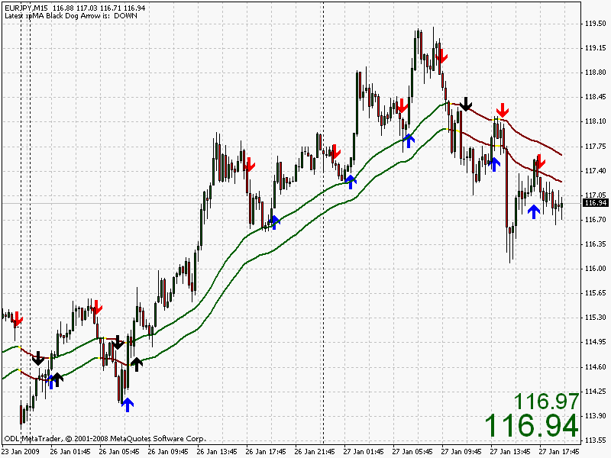

It is very possible to trade the MTF as in Chart #1 without the indicator to assist. Some might ask if the indicator is an aid, or if it is a hindrance. Well, I'm inclined to side with the former whereby there is some confirmation of the signals. But I hasten to add that I am not a fully paid-up member of the indicator club, I have my reservations, they only indicate after all and nothing is written in stone. Blessed are the traders who trade with absolutely nothing on their screen but candles (bars), and maybe the odd trendline. I cannot hope to enter their league. But it adds to the dictum of having less on the screen, the better. Having a confirming indicator doesn't harm the odds that we have managed to gain.
Nothing else is required to make this system work. It is very simple so why complicate matters further? I've been down the road of having all the indicators known to the civilised world staring at me. Believe me, I've tried 'em all. Result? It cost me! So....... thanks, but no thanks.

CHART #2 THE FULL MINI-TREND FINDER
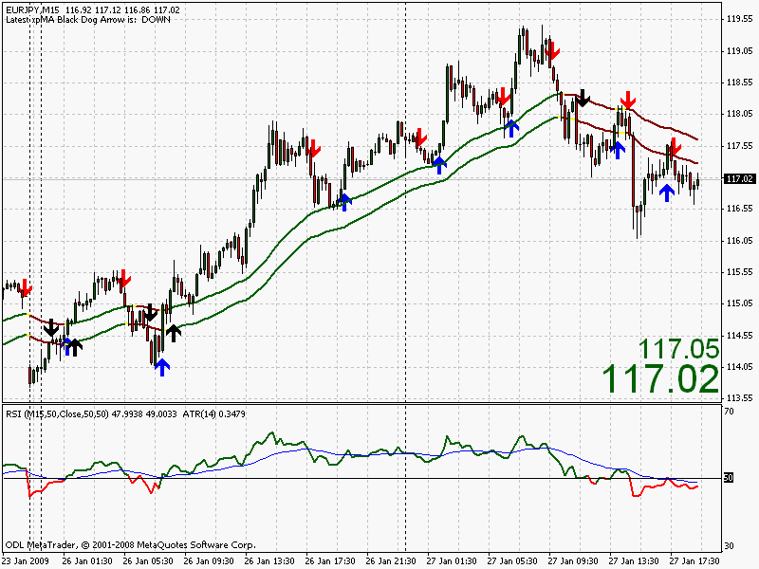

The first point to make is that there is nothing wrong with the RSI as we now have it. It does its job of confirming the trends for us. The superb coloured 50 emas also keep us on the right track (pun intended) and we should not find ourselves trading long when we should be short and vice versa. For example; the RSI is green for long, the Color MAs are green for long, THAT is our direction to trade.
There are three ways to enter our trades; 1. using the SES; 2. using the Black Dog entry; and 3. using the Hi/Lo entry; all as described in the Black Dog and the MTF text.
Without putting too fine a point on it, that is the system in a nutshell. BUT there is two aspects of the set-up in chart #2 that bothers me constantly. First is the jaggedness of the RSI. It does not make for easy reading of the indicator. Ok, it's green, it's confirmed the up move. Fair enough, that's all we ask really. But the 25 ema tells us to exit on occasion. Trouble is, you just cannot have any idea if it's going to jump below its ema or not at any particular time. Right from day one, I have not been 100% happy with that aspect and therefore the problem has been needling me ever since. So what can be done?
The easy option is to leave the RSI on but make the colour 'none' then have a 3ema as a proxy to take out the jaggedness leaving a much smoother line. This loses our 'colour code' option for the RSI though, and it would be a shame to lose this, I think it helps a lot. This is ok but not really what I am looking for to assist me and all those traders who struggle to read a zig-zagging indicator. Let's face it, the smooth-lined indicators present enough problems without all those zigs and zags. Best to leave the current set up of the MTF1 as is.
The second aspect that bothers me is that there are often valid signals after a good move has ended and the next valid signals are in the same direction of that move but occur when the market is starting to reverse, it's starting to turn around and move in the opposite direction. Chart #3 shows this more clearly whereby the SES agree with the RSI but the down move has clearly ended. This can be costly. Our only saving grace is that the RSI is above its 25ema, so no trade. Which brings me back to the first point regarding the jagged indicator, is the damned thing going to cross or not? They are very difficult to read.

CHART #3 THE END OF A MOVE
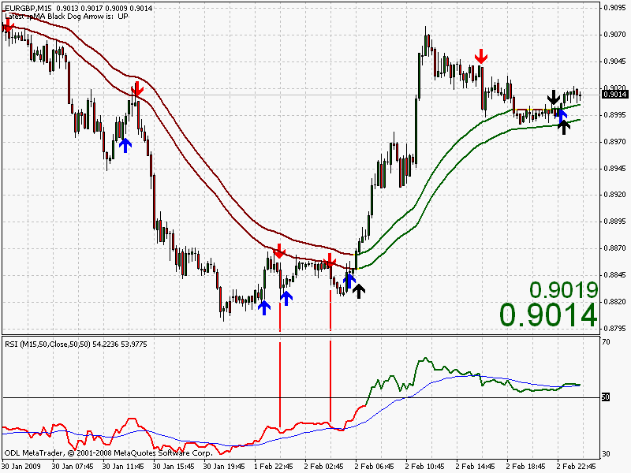

Ignore the timings of the SES signals in the chart above, it's simply an example and could occur at any time throughout the day if you are trading intra-day. The whole point of this exercise is to give traders a choice of indicator when trading the MTF. It's all right saying that we'll use something else and upload a few charts saying, ''there you go'', but it's better to give the reasoning behind it too. Anyway, those points are what has been bothering me for quite a while and it would be pretty good if we could improve on it.
So, let's concentrate on a MTF2 alternative which basically makes it easier to read but must also give excellent confirmation of trend, and hopefully subsequent entries.
Now don't take my word for this but I honestly believe that most indicators are not up to the job. I've spent years playing with them with various variations of various varieties (!) and ditched them one after the other. For me, they just do not perform at all. The only true indicator is price itself.
But I have always returned to just two indicators - the RSI and the Macd. In twelve years of trading, these are the only two that come anywhere close to what I want an indicator to tell me, to reassure me, and to have a good percentage of correct calls. We have the Macd on the Black Dog, the RSI on MTF1, let's look at the Macd as an alternative to the RSI on the MTF2. Consider chart #4 below with the macd set to the current time frame.

CHART #4 MINI-TREND FINDER with our standard MACD
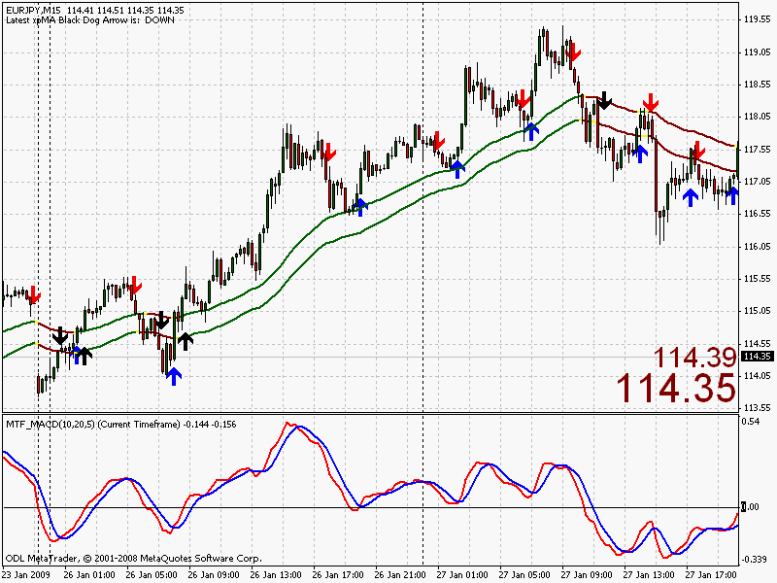

Let me explain the Macd settings. By the way, please don't alter any of your chart settings just yet, we'll make that easier for you at the end.
Our normal Macd setting is 10,20,1. If we use 10,20,5 this will give us a faster Macd line to play with. See how closely the two Macd lines follow price with the red crossing the blue at retracements in the trend. In fact the Macd nails those turns in price rather nicely. This doesn't really help much as we could get two emas to do a similar job. And, as Black Dog traders, we only trade with the trend anyway, the SES provide our signals there. So what use is it then?
Well, if the Macd nails the turns on a 15 min chart, it should do it on a 60 min chart too, so let's have a peek at that time frame.

CHART #5 60 min EURJPY with 60min MACD
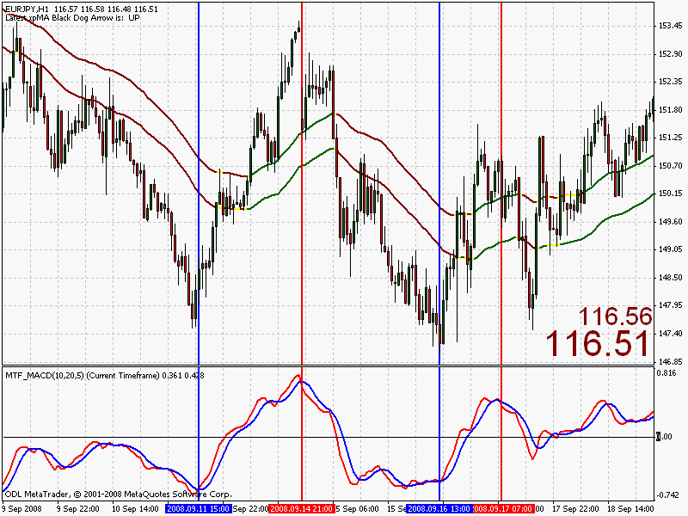

You can see here that the Macd pretty well finds those turns in the market too. If that red line is above the blue, price rises. And vice versa. There are some minor crosses on the Macd above that are not marked by a vertical line, but please bear in mind that this is simply to describe the indicator and to get the meaning across.
Remember multi-time frame trading? If we know what's happening on a higher time frame we have a better chance. Words that spring to mind are 'odds' and 'edge'. Do you remember those also? We need them. So, if we can get a Macd that nails those turns in the market with the same accuracy as on chart #4, but on a higher time frame, then we're laughing!
Chart #6 has utilised the zoom feature so as to show the previous charts' vertical lines but on a 15 min time frame. The trends are there to see. In addition, we have the Color MAs to help us with trend. Ok so far?

CHART #6 EURJPY 15 min with 60 min MACD
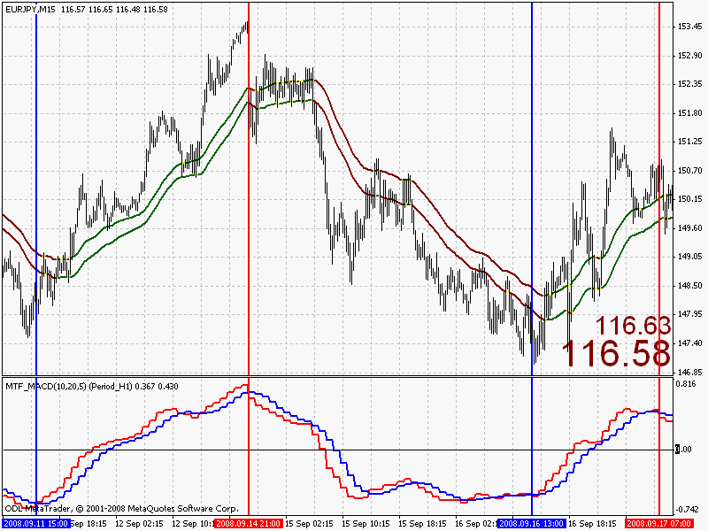

CHART #7 It's now a simple matter to add the Dogs and the SES.
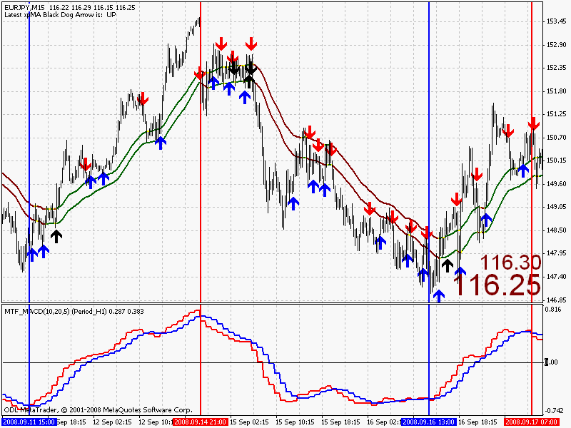

What have we looked at so far?
A 15 min chart with a 15 min Macd. Looks good.
A 60 min chart with a 60 min Macd. Also looks good
A 15 min chart with a 60 min Macd. This also looks very good.
But it still looks a bit zig-zaggy to me!
Ok, thanks to wolfboy we have an indicator that makes things easier on the eye. Chart #8 shows this. We are not too bothered about the blue line, but the red grabs our interest because we want to see where it is, and hopefully where it's going. It tends not to jump all over the place as with the RSI therefore giving a better indication of direction. Also, having your correct zoom to your trading chart gives a much better-looking Macd as you'll see shortly. With chart #8 we have zoomed too far out to trade but it does show the big picture which is no bad thing.

CHART #8 A SMOOTHER MACD FAST LINE
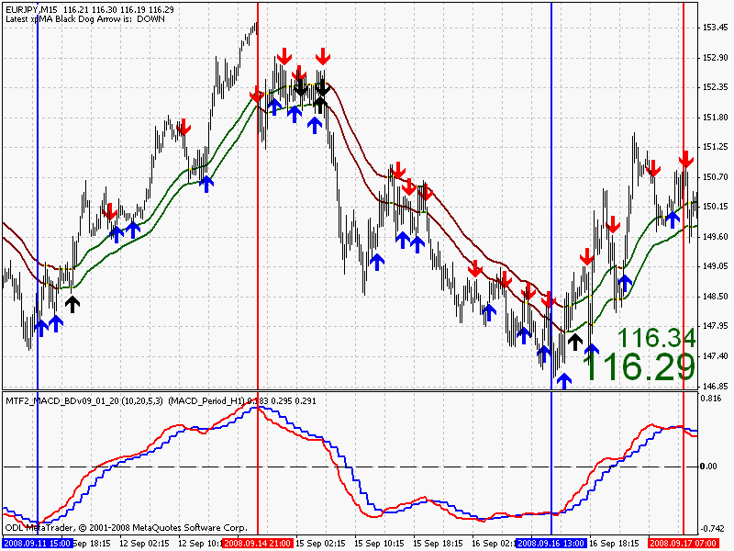

Let's zoom in a little and look at the first trend of Chart #8. The zoom is still a bit much but it shows that first full trend and the smooth red line that we want to see above the blue in an uptrend.

CHART #9 EURO UPTREND
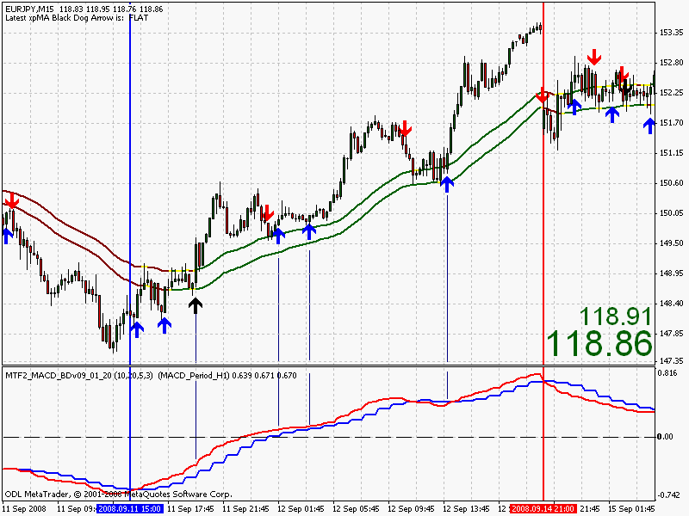

Well, that's the chart set up and the basics. Let's look at the original trades shown on chart #3 to see if we have made things any clearer. To my mind we have. The jagged zig-zags have all but gone; and, in this case at least, it's shown us that the market is turning. The RSI may have told us to enter, but here it's clear cut.

CHART #10 EURGBP 15m with H1 MACD
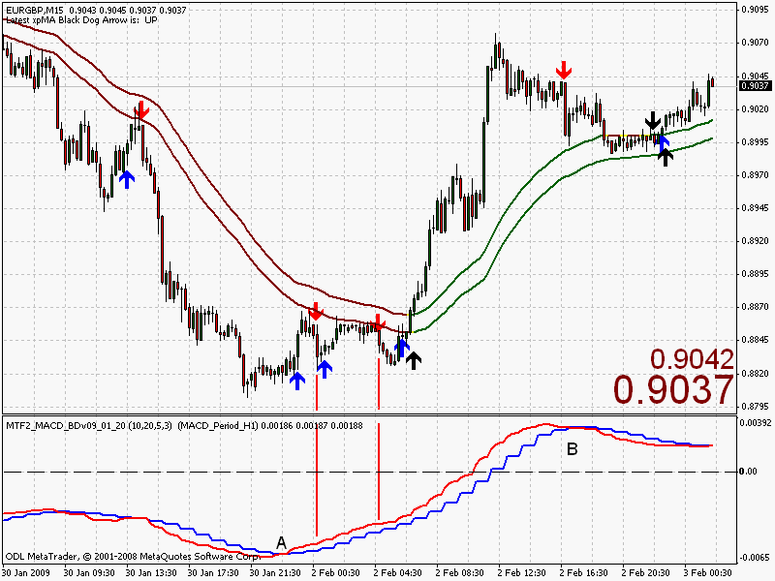

Ahh! that's better. The Macd would certainly have helped us in this case by keeping us out of those two short trades. The fast, red Macd line crosses at 'A' so trades from this point should be to the long side only.
All we have done here is to offer a choice of indicator for use with the Mini-trend Finder system - the RSI or the Macd - I'm sure that whichever you use, they will serve you well.
On the next page we'll go into a little more detail which should help you decide which one is for you.
MTF2 - page 2

So, without too much pussyfooting around, let's get straight down to it. I would normally place a chart here to show where we are up to at this point with a quick recap to keep the story going. This isn't necessary as we know all about the Black Dog system, the Mini-trend Finder, SES, the Color ma's, Macds and RSIs etc., and all the rules for trading these systems especially the entry rules. We are also well versed in the use of STOPS & TPs. Our money management is up to speed and we have also read (digested, and acted upon) the Article on making our trading rules!? So how can we fail?
Mmmmm!
We need to look at the big picture again to start to understand the workings of the Macd in relation to the settings we have in the price window above it ie, the Color ma, the Black Dogs, and the SES. Charts #11a and 11b show the 15 min timeframe again simply because this is the TF that I trade. No other reason. The first point that we need to bear in mind is that we have a zero line on the Macd indicator which is represented by the black dashed line.
The first chart clearly shows that the macd remains below its zero line while price remains in a down trend, with the second chart showing the opposite. Notice the colour of the 50s.
So if price breaks above the 50s, and the Macd is anywhere above the zero line, it's a goer?
It would certainly seem that way so far. But again, at this point, it's safe to say that if price breaks below the 50s and the Macd is above its zero line then it is not a goer, it is not a trade.

CHARTS #11a & 11b THE BIG PICTURE
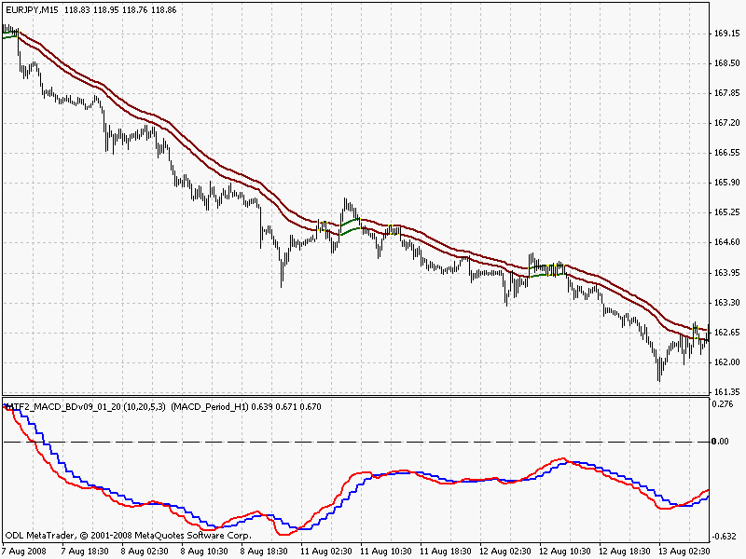
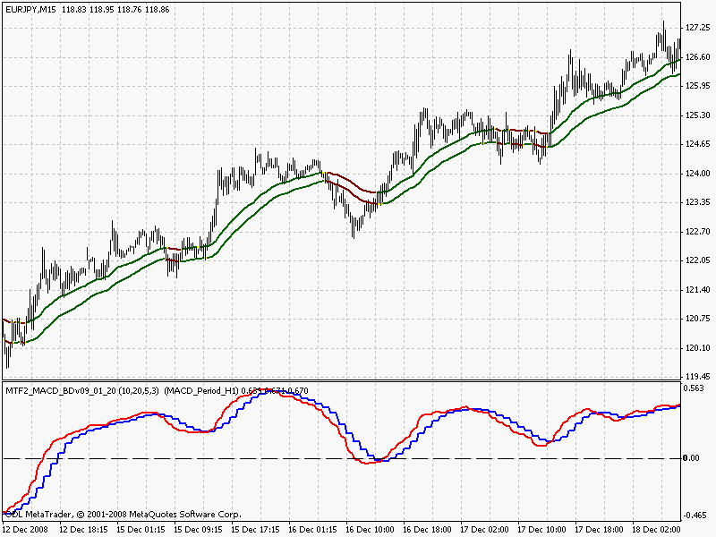

Now, by saying the Macd is above its zero line let's assume we mean the red line. We can look at another chart (#12) which does not have those great trends but we can get a feeling for how the Macd can help us. Those highlighted trades below wouldn't have been taken as the Macd told us that the market was turning.

CHART #12 DOWN, UP, DOWN, UP TREND!
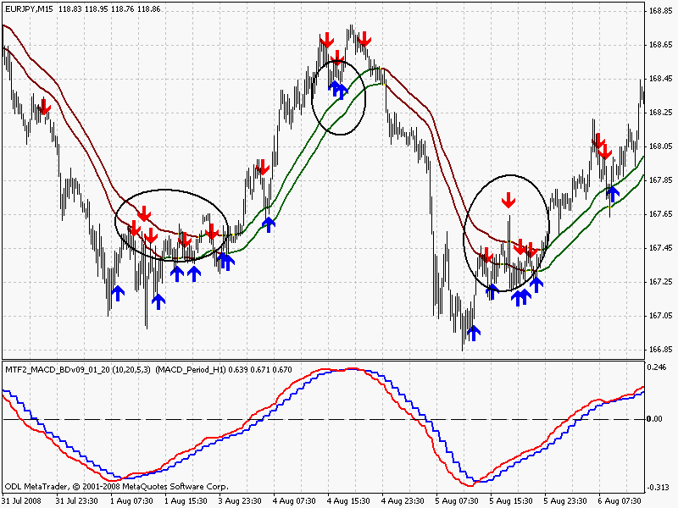

Those areas marked above are where the majority of losing trades are made. Hopefully the Macd will eliminate a good percentage of them. There is simply no way of eliminating them altogether but you will find that this adds to your edge.
It was mentioned in the Mini-trend Finder (MTF1) that the 50s are used as a guideline and to take the SES if the RSI agreed according to the rules. I must say that I find it very difficult to take a trade whereby the signal is not from a bar that hasn't closed, say, above the 50s for a long position. It is ingrained into me. We have two types of SES; the first is an initial break of the 50s on a trend change, the second is when the trend has been in place for some time, retraced some, then continues in the same direction. The first red arrow on the chart above , the last blue arrow, and the blue arrow just left of centre on the up leg of that trend are instances. In all cases the Macd is on the correct side of its zero line. No problem there.
What about an initial break above/below the 50s which could be denoting a trend change?
The next chart shows exactly that. The Color mas have changed. Would you have taken the trade bearing in mind that the Macd is above zero?

CHART #13 TREND CHANGE?
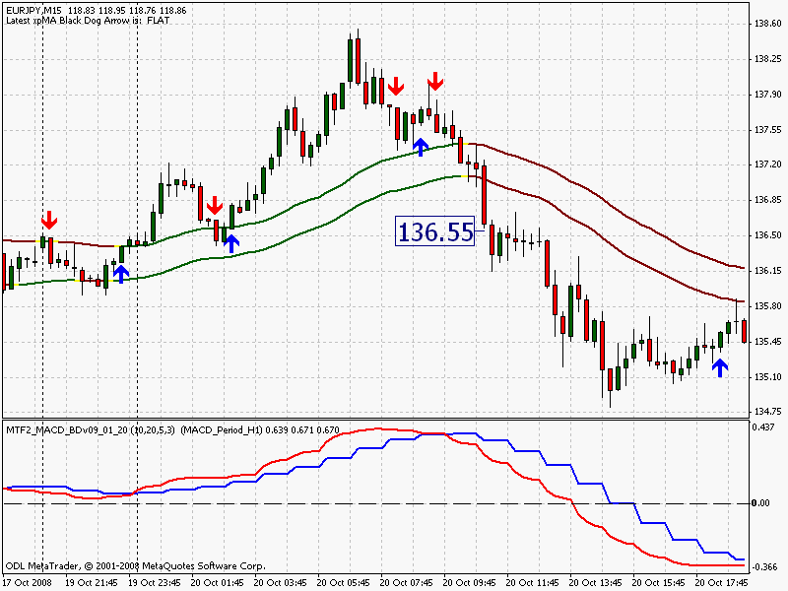

I definitely would have. Although the Macd is positive (above its zero line), the red is below the blue which means it ain't going up! It may go flat, it may go down. The Color mas have changed, with price on the correct side, and the red Macd is below the blue Macd. You could go with smaller lot size but I would still have taken this, half normal lots probably. An aggressive trader, me? Well yes, but with those smaller lots maybe you could describe me as a semi-aggressive trader. Or, on the other hand I could be semi-conservative!

CHART #14 GO, or NO GO
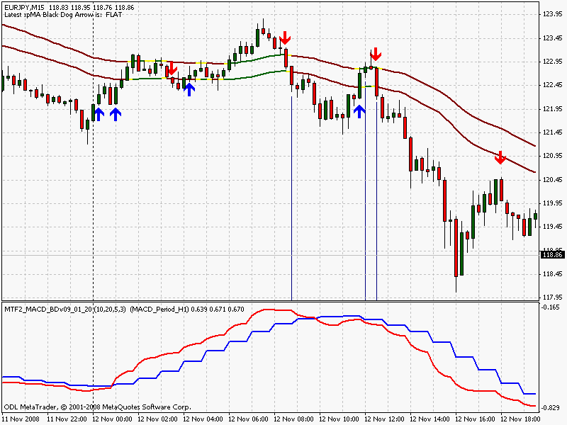

There are three possible trades on chart #14. Only the third is valid.

CHART #15 FLAT MACD
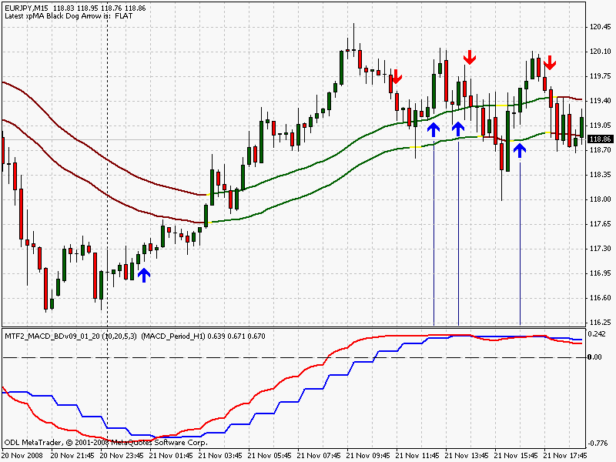

A flat Macd tells me that there is lots of indecision. The fast red is travelling sideways. Time to go looking for another pair. Or carry on with the washing-up and wait for the next SES signal.
If you miss a trend change signal try the Hi/Lo entry. I know I keep harping on about this but it is well worth keeping your eye out for.

CHART #16 THE HI/LO ENTRY
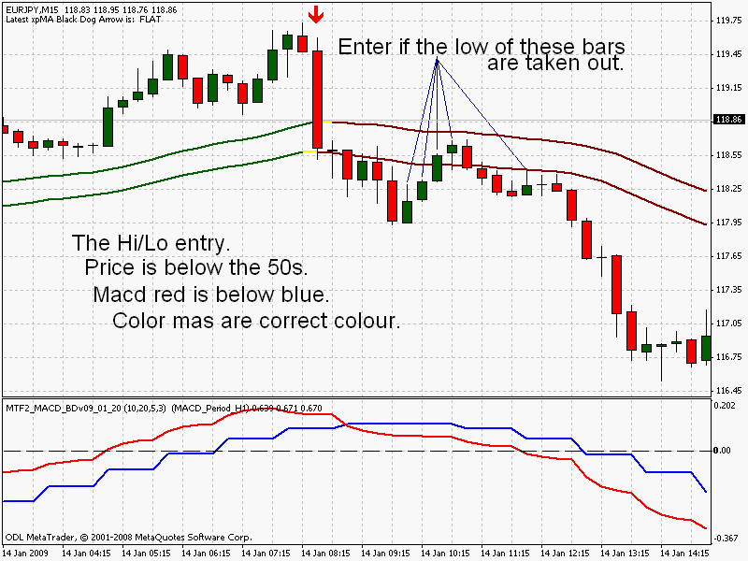

As we have excellent trend indication with the Macd AND the Color mas you will notice that the Black Dogs have been omitted from the previous charts. This is an option should you wish to keep your chart ultra-clear, but I can't live without 'em.
Another option is to place a 15ema on your chart to give you an idea of price movement after the appearance of the SES. The aggressive trader may prefer this when negotiating a trade such as that below. The standard entry would be around the 114.20 area. The Agg trader is looking to get in earlier.

CHART #17 15 EMA ADDED (option)
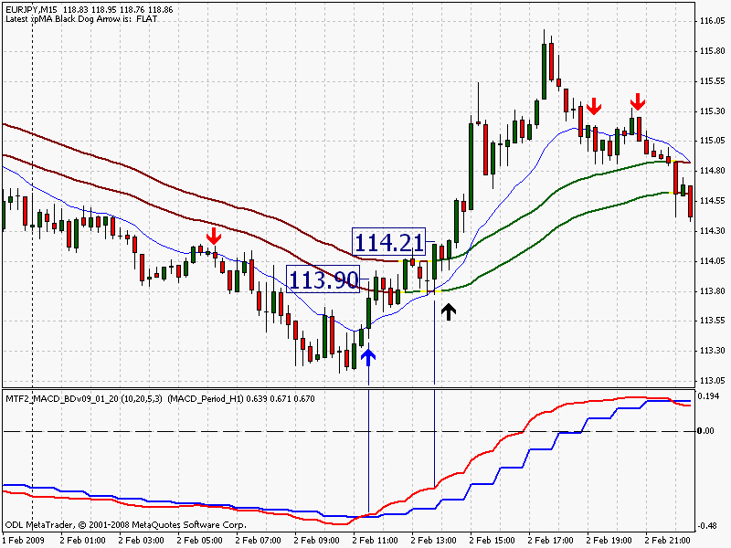

Slowly but surely the Black Dog program is evolving. One BD trader who has been testing MTF2 has reported that he will not go back to the RSI and, although I'm not particularly interested in history, he reports a very good success rate for trades over the last two months. More than 75% if long trades are taken when the Macd is positive, and short trades are taken only when the Macd is negative. This of course reduces the number of trades taken and many good moves are missed. Some bad trades are avoided too but this all depends on your style - aggressive or conservative.
It could possibly be a good idea to lower your lot size when trading aggressively with signals occurring when the Macd is on the wrong side of the zero line.

In Summary:
a) Only take trades if the red Macd agrees by being above the blue for longs, and below the blue for shorts.
b) If the Macd is above its zero line; we can assume an up trend. Vice versa for below the zero line.
c) Similarly, the Color mas and Black Dogs also determine trend.
d) Conservative: SES and/or close above 50s BUT Macd must be above its zero line, and above its blue line for long trades. Vice versa for shorts.
e) Aggressive: SES and/or close above the 15ema (if plotted, optional), red above blue on Macd.

IMPORTANT:::
Because of the way it is constructed, and in very long sustained trends with little or no retracements, the Macd can show false readings. An example could be something like a three day uptrend with no retracement on a 15 min chart. What happens is that it starts to turn and move in the opposite direction to price. This occurs very infrequently, in fact I am having trouble finding an example. I will in the near future but it is something to be aware of in the meantime.
Most strategies require a good length of time to go through the testing phase and the MTF2 is no different. Two months for this strategy is hardly any time at all but I did ask three or four other BDog traders to test it. They liked it, to be blunt.

Addenda ::: I intend to add to these writings shortly with the intention of making things clearer and with more examples. There has been a bit of a rush to get it to the website.
Further information on the Macd indicator.
wolfboy has done a brilliant job on the indicator which enables us to employ it on any time frame. Even the 1min TF looks good! Previously we had to enter the details each time we switched periods.
Download the MTF2_MACD_BDv09 indicator.
Going on recent history, a small number of people will have problems downloading the indicator. I cannot fathom out why. If you do experience this, drop me an e-mail with MTF2 in the title and I'll get it off to you.

